Shrimp Task Force Meeting Minutes
Wednesday, July 10, 2024, 10:00am
Terrebonne Parish Main Library
151 Library Drive, Houma, LA

I. Pledge of Allegiance
II. Call to order
III. Roll Call
Voting Members Present:
Rodney Olander
Acy Cooper, Jr.
Lance Nacio
Kristen Baumer
Andrew Blanchard
Randy Pearce

Voting Members Absent:
Jeff Drury, III
Phillip Tran
Alan Gibson
Chalin Delaune

Non-Voting Members Present:
Neal McMillian
Peyton Cagle
Jack Isaacs

Non-Voting Members Absent:
Edward Skena
Gene Cavalier

IV. Rodney Olander motioned to approve the May 1, 2024 meeting minutes, 2nd by Acy Cooper. Motion carries.

V. Rodney Olander motioned to amend the agenda by adding an item, F. To Discuss Shrimp Genetic Testing- Seed Consulting, 2nd by Lance Nacio. Motion carries.

Rodney Olander motioned to accept the agenda as amended, 2nd by Acy Cooper. Motion carries.

VI. Financials:
Remaining Fund Balance- $676,273
Remaining Budget Balance- $147,161

Acy Cooper motioned to accept the financial report as presented, 2nd by Lance Nacio. Motion carries.

VIII. New Business

Jason Froeba provided an update on the Equipment Modernization Grant Program
1700 applications that are deemed good in the system, 736 approved or are in some part of the review process, 301 of these have been paid or are approved for payment status, one of the issues is the time is takes to process an application, estimate was originally 4.5 hours and it’s actually taking 8.5 hours to process any given application, looking to get a broad range of supplies approved for reimbursement, the less we have to deny the faster things will go, concerns about supplies since we didn’t start off that way and many people were already in process, there are less than 30 people who would be impacted by this change and it was a small enough number for us to go back and change this for those applications, payout so far is $8.47M

Ida Program; it is a direct payment program based on your license and trip ticket information, the only caveat is if you are a processor and you don’t have any trip tickets you may have to submit some information to LDWF for payment, dealers, commercial fishermen, vessel owners will use trip ticket data, program is statewide, 3 components to payment- base payment, then a payment based on your trip ticket data and losses- no loss requirement, but if you did have a loss you will get an extra payment based on your loss, 3rd component payment that was based on revenue, spend plan on website, processors were added in later, sent the plan over to NOAA on June 10th; 20% base payment, 20% revenue payment, and 60% loss payment

B. Cole Garrett provided an update on the shrimp legislative update

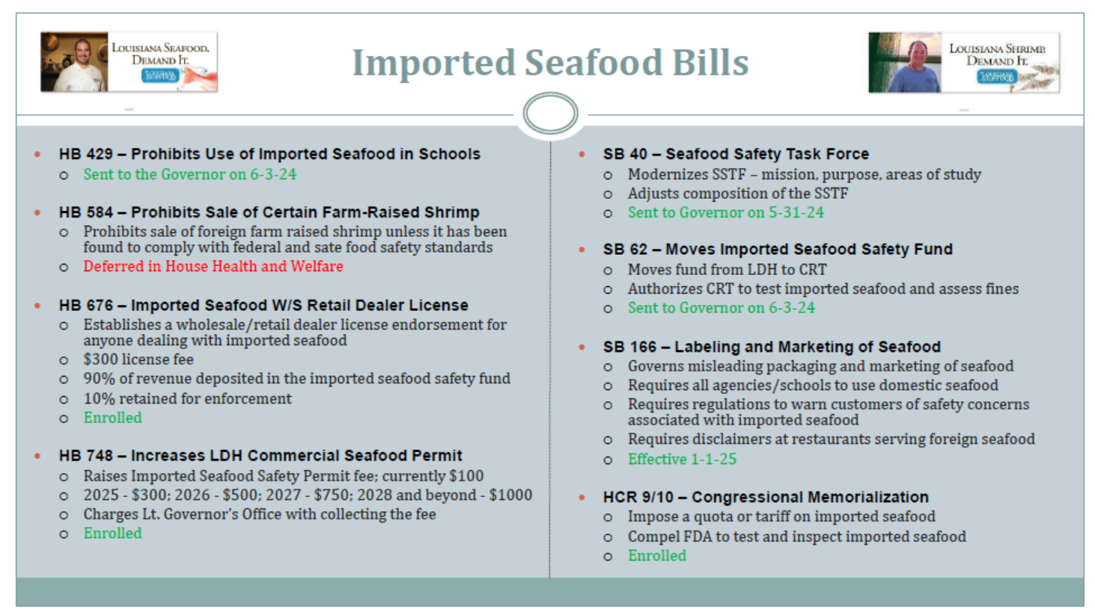
Cole Garrett stated that there is specific questions about how testing is going to be done, how enforcement is going to be done. Unfortunately, that's pretty much going to fall outside of the purview of Wildlife and Fisheries and going to be more vested with the seafood promotion and marketing board as well as Commissioner Strain’s Department of Ag.; SB166 under Ag and Forestry

Kristen Baumer stated that the task force should facilitate getting the key organizations together (LDWF, LDH, LDAF, CRT, SPMB) who will be enforcing these laws and coming up with the regulations that deal with all of this new legislation, Cole Garrett stated that he is happy to help facilitate this meeting

Jack Isaacs, import summary statistics, tally of seafood imports from January 1 to end of May 2024
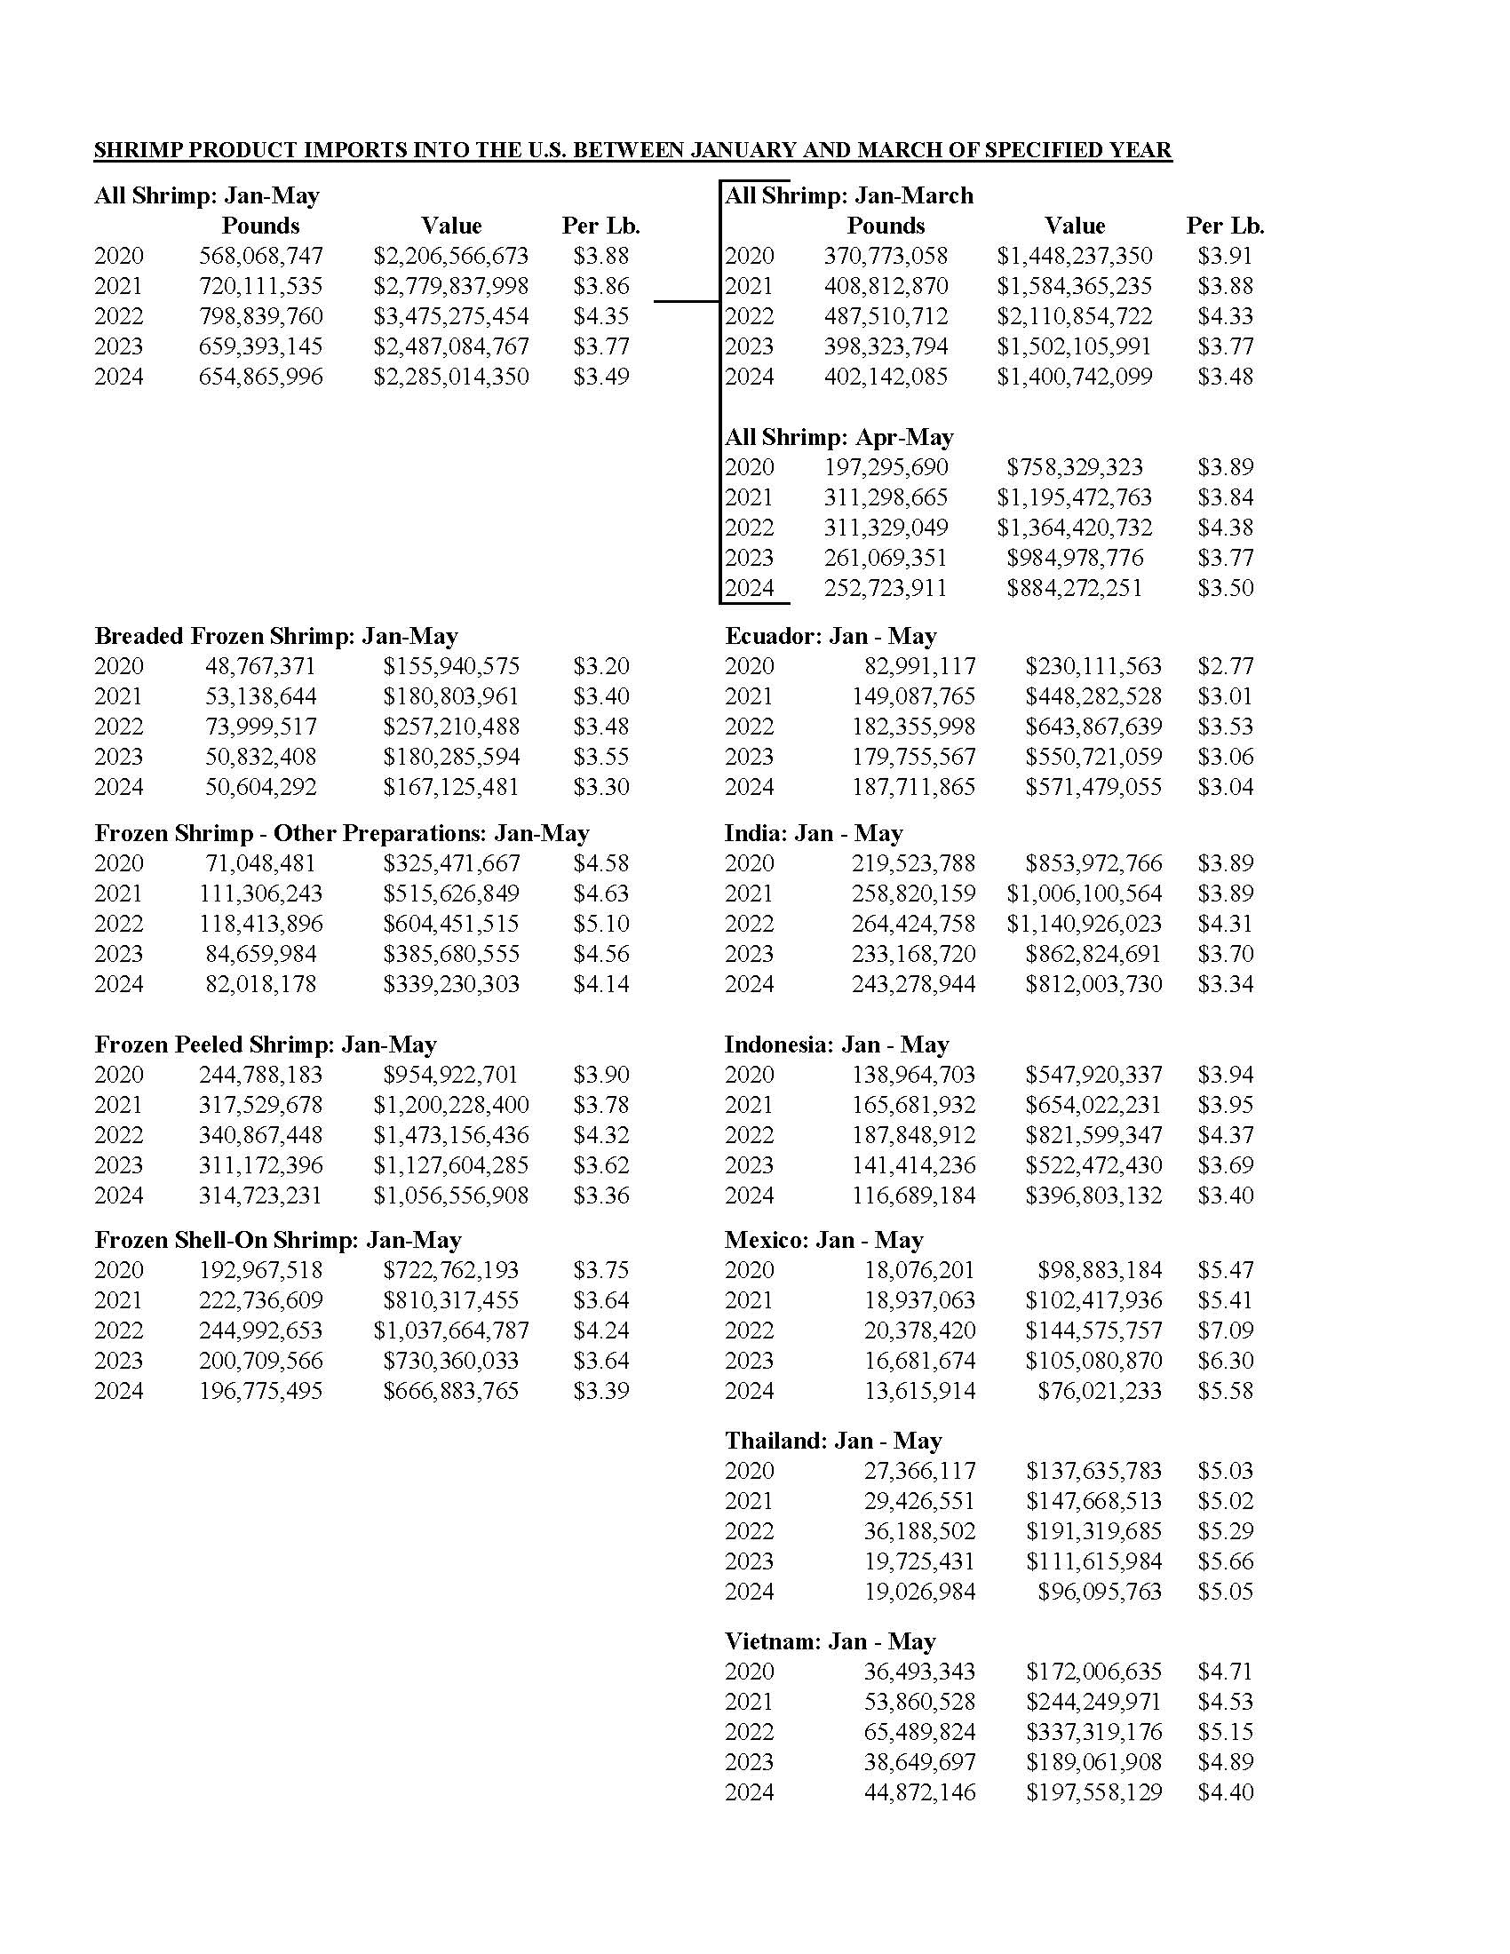

C. Andrew Blanchard led discussion on the possible re-opening of white shrimp season

Andrew Blanchard white shrimp already at a marketable size from industry findings, this was put on the agenda because hearing from fishermen that there are not enough fishing days in the year to fish, would like to discuss further

Rodney Olander stated that the only thing that can really be done is to request that the LDWF biology department stay on top of it and report back if there are findings that indicate an opening is needed

Acy Cooper stated that he relies on the data to tell us when the resource is ready, if it warrants opening by all means open it but don’t open prematurely as you can hurt the resource. Have to be careful reopening when the small shrimp will be coming in, suggested leaving it to the biologists and see where it goes

Andrew Blanchard requested some feedback on the progress of shrimp report prior to LDWF Commission meeting

D. Peyton Cagle led discussion on the STF designating a representative to attend upcoming BOEM off-shore wind development meetings; NOAA announced that they will be hosting some meetings in Lake Charles and Cameron Parish, holding public comment meetings to bring up some of the issues, that way moving forward with these processes and applications of wind mills farms we can formulate a way to rate and grade these projects, goal of this item on the agenda was to make sure the task force was aware of the meetings and if the task force wanted to have representation that they would designate a representative to attend
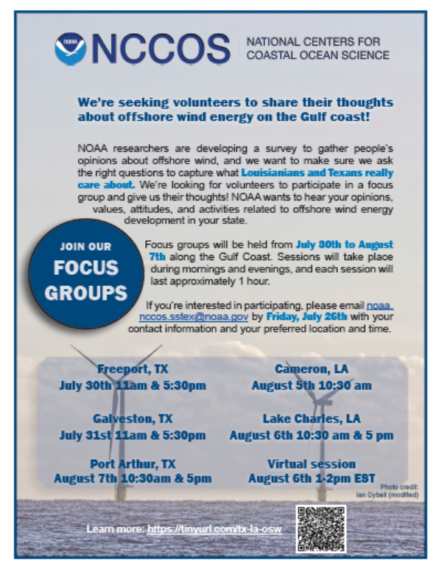
E. The task force deferred discussion on LDH nutritional labeling regulations to a future meeting

F. Davis Williams of Seed Consulting led discussion on the rapid genetic testing

David Williams stated that the rapid genetic test is inexpensive, is portable and it works, it will identify shrimp with a high degree of accuracy and it’s available, knows that talking to governmental bodies is difficult but would like to shorten the gap between the technology and those agencies who are enforcing these issues, volunteered to visit agencies to demonstrate the test and prove the accuracy, should be including the crawfish in testing, region of location can be determined by the genetic testing not rapid but available within 3-4 days, willing to take up the task of going down rabbit holes of finding people, need the agencies to realize that restaurants need to be held to the same standards as the retailers, if the task force is interested and wants to designate him as authority to reach out to LDH on the industry’s behalf he would be willing but needs approval from the task force

Lance Nacio stated that he would be willing to make a motion to approve David Williams to meet with Mike Strain to provide a presentation about the rapid genetic testing

LDAF, LDH and CRT, and three TF members to meet with agencies to discuss upcoming legislation and how it will be enforced, Governor’s office committee, LDWF, STF members- Kristen Baumer, Acy Cooper, Andrew Blanchard

G. Andrew Blanchard requested that LDWF provide photos in future shrimp reports

Peyton Cagle stated that he will run this up the chain and if there are no issues he will be happy to provide photos in upcoming shrimp reports

H. The task force decided to wait to schedule their meeting training at the next meeting

IX. Peyton Cagle stated that CPRA Diversion Operation meetings want to put this on the task force’s radar, would be important to have representation at CPRA meeting, helpful to hear concern from industry on the operational plan, date for this meeting should be set at the next CPRA meeting

Rocky Decharo stated that he would like to be able to address the issues when they are heard on the agenda as opposed to being held until the end to make comments, what on this agenda will help shrimp prices in August, nothing, the industry is going to die if prices do not go up, where is the lobbyist that the STF hired have not heard from them, to hear the topic about reopening the white shrimp season, when the shrimp season is closed the live bait boats should be shut down as well, stop live bait boats working in March and April, when it closes on the 3rd Monday let’s close it all the way to the 3-mile,

X. Next meeting set for Wednesday, July 31st for 10:00am at the Terrebonne Parish Council Chambers

IX. Rodney Olander motioned to adjourn the meeting, 2nd by Kristen Baumer. Motion carries.

