Shrimp Task Force Meeting Minutes
Wednesday, May 1, 2024, 1:00pm
LDWF Headquarters
2000 Quail Drive
Baton Rouge, LA 70898

I. Pledge of Allegiance
II. Call to Order
III. Roll Call
Voting Members Present:
Acy Cooper, Jr,
Andrew Blancard
Rodney Olander
Kristen Baumer
Lance Nacio
Alan Gibson

Voting Members Absent:
Jeff Drury, III
Phillip Tran
Randy Pearce
Chalin Delaune

Non-Voting Members Present:
Peyton Cagle
Jack Isaacs
Neal McMillian
Gene Cavalier

Non-Voting Members Present:
Edward Skena

IV. Rodney Olander motioned to approve the March 6, 2024 meeting minutes, 2nd by Acy Cooper, Jr. Motion carries.

Acy Cooper, Jr. motioned (1) to amend the agenda by taking up item C. To Hear a Shrimp Legislative Update as item A under New Business; (2) to add an item to the agenda, C. To Hear an Update on the Difference in Price Per Pound on Imports vs. Domestic Shrimp for the Last Five Years- LDWF; (3) to add and item to the agenda, H. To Discuss the Indian Shrimp Whistle Blower- STF, 2nd by Rodney Olander. Motion carries.

Acy Cooper, Jr. motioned to approve the agenda as amended, 2nd by Lance Nacio. Motion carries.

VI. Federal Shrimp Permit Report

VII. Financial Report:
Remaining Fund Balance- $676,273
Remaining Budget Balance- $147,161

Acy Cooper, Jr. motioned to approve the financial report as presented, 2nd by Lance Nacio. Motion carries.

VIII. New Business
- Duncan Kemp provided the task force with a 2024 legislative update

HB1- The Appropriations Bill; the only thing here is the line item that deals with the interagency transfer from CPRA to the Shrimp Task Force for marketing projects

HB429- from Representative Bryant; the bill would prohibit the use of imported seafood in school food programs; this is pending the Senate Education Committee actually for hearing today, there was an amendment made that would also require that the State Capitol cafeteria also no longer use ay imported shrimp

HB460 companion bill in the Senate, 273, Representative Kerner and Senator Hensgens; That would clarify that full-sized trawl gear is permissible for bait. Shrimp vessels fishing under permit, The House Bill is pending the Committee Natural Resources and the Senate Bill is pending House's final passage
HB584- Representative Kerner; applicable to aquaculture products Farm bill, pending House and Welfare Committee, considered on April 4, deferred at the House Health and Welfare Committee

HB676, Represenative Kerner; would establish seafood, importer license for wholesale retail dealers and retail dealers to handle any imported shrimp, crawfish, or crab. This is a staggered fee structure based on pounds of seafood; pending Senate Natural Resources Committee; as part of the bill, 90% of the revenue would go to the LDH’s imported Safety Seafood Safety Fund for testing, and 10% would go to Wildlife and Fisheries for administration and enforcement; the task force was concerned with importers going through another port of entry to bypass the fees and regulations; how is this going to be policed? Duncan Kemp stated that he would follow up on this
Proposed fee schedule:
- 0 to 5,000 pounds would be $500
- 5,000 to 20,000 would be $2,000
- 20,000 pounds to 40,000 pounds would be $5,200,
- and it goes up to 500,000, and one or more would be 100,000.

HB693, Representative Bayham; similar to HB676 but the fees are slightly different, and its all imported seafood and deposits all fees to LDH as opposed to the 90/10 split with LDH/LDWF, pending passage on the House Floor, failed in the House and Governmental Affairs Committee on April 17, the vote failed

HB748, Representative Domingue; provided relative to import seafood safety fees, original bill increased imported seafood safety fund, directs funds to the LSPMB; The original bill Increased cost of the LDH Commercial Seafood Permit from a fixed $100 a year to one tenth of a percent of gross revenue of the processor or distributor annually and directed proceeds to go to the Imported Seafood Safety Fund. the Senate amendments changed the fee to a fixed $200 and directs money to the Seafood Promotion and Marketing Board to sample, analyze, test, and monitor raw seafood of a foreign origin. It repeals the LDH Imported Seafood Safety Fund, and directs all revenue to the Seafood Promotion and Marketing Fund; this bill is pending the Senate Natural Resources Committee

HCR 9; Representative Kerner; It memorializes Congress to impose a quota or tariff on imported shrimp, crab meat and crawfish, and to enact a purchase plan for domestic products. That also is pending Senate Natural Resources Committee

HCR 10, Representative Kerner; memorializes Congress to compel the FDA to fulfill its duties regarding the inspection and testing of imported seafood; scheduled for today in front of the Senate Committee on Health and Welfare.
SB40, Senator Allain, It provides for the modernization of the seafood Safety Task force updates the mission and purpose provides for enhanced areas of study; adjust the composition of the seafood Safety Task Force, including adding a member of the STF, a commercial fisherman and a commercial processor. That's pending House Committee, Health and Welfare.
SB62, Senator Fesi, This provides relative to seafood safety as well; it moves the Imported Seafood
Safety Fund from LDH to the Culture, Recreation, and Tourism Department; It requires commercial seafood permits to be divided into separate classifications for distributors and processors. It authorizes Culture, Recreation, and Tourism to test imported seafood requires them to contract with LDAF this Ag. To sample, analyze, and test to seafood, and authorizes culture, re recreation and tourism to assess fines that passed Senate on April 30, 2024

SB166, Senator Connick, It establishes the provisions within Department of Agriculture; statutes, governing, misleading, packaging, and marketing of seafood requires all agencies, institutions, or school districts, to use domestic shrimp or crawfish; requires regulations to ensure that consumers are warned of the safety concerns associated with foreign seafood products, and requires disclaimers to be displayed at restaurants serving imported seafood, and that is pending the final passage in the House
Rodney Olander Acy Cooper stated that Connick’s bill went to the House and passed the House floor put an amendment to it so it needs to go back to the Senate for approval this is the main one, puts fines behind restaurants (SB166)

Gene Cavalier stated that he spoke to some inspectors, already do label inspections; LDAF will be proactive, 65 state wide on weights and measures

Peyton Cagle stated that the interagency transfer of the $50,000 from the STF account to LDH has not gone through as it is still being processed. There was a hangup with it. It went down a different road than what we originally thought. It is currently pending signature through LDH, so hopefully soon

Dave Williams with Seed Consulting stated that they have a rapid genetic test to identify species of shrimp; checking labeling is a great thing but it doesn’t do a ful belt and braces test; Gene Cavalier stated that what we'll be doing from the Department of Ag is checking country of origin versus false advertisement, like, we'll talk about the Boudreaux’s aspect and things of that nature. That's the labeling aspect we'll be checking. Dave Williams stated that the State needs to address deceptive business practices and this is a great way to do that; the costs associated with the testing- the hardware is $3,000, it's portable; It'll do 16 tests per cycle. It takes 2 hours to do the tests, So you're talking about 22 bucks to get a validation, which compared to DNA testing is about a tenth of the price.
- Peyton Cagle provided a presentation on shrimp data trends and the 2024 inshore shrimp season recommendations

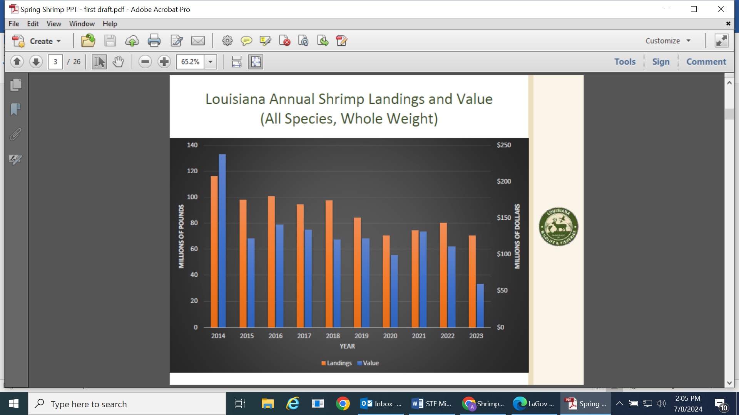

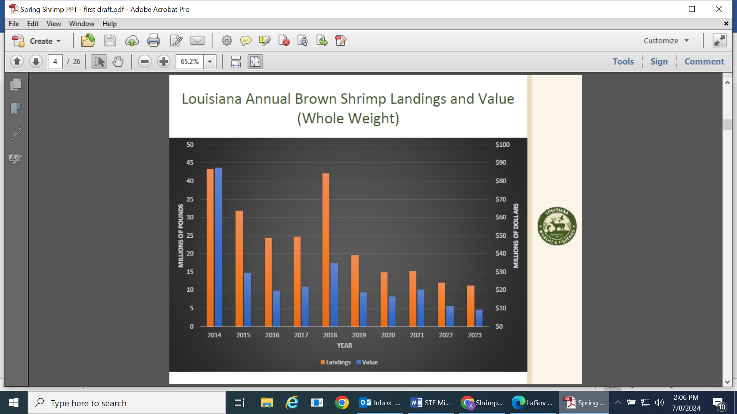

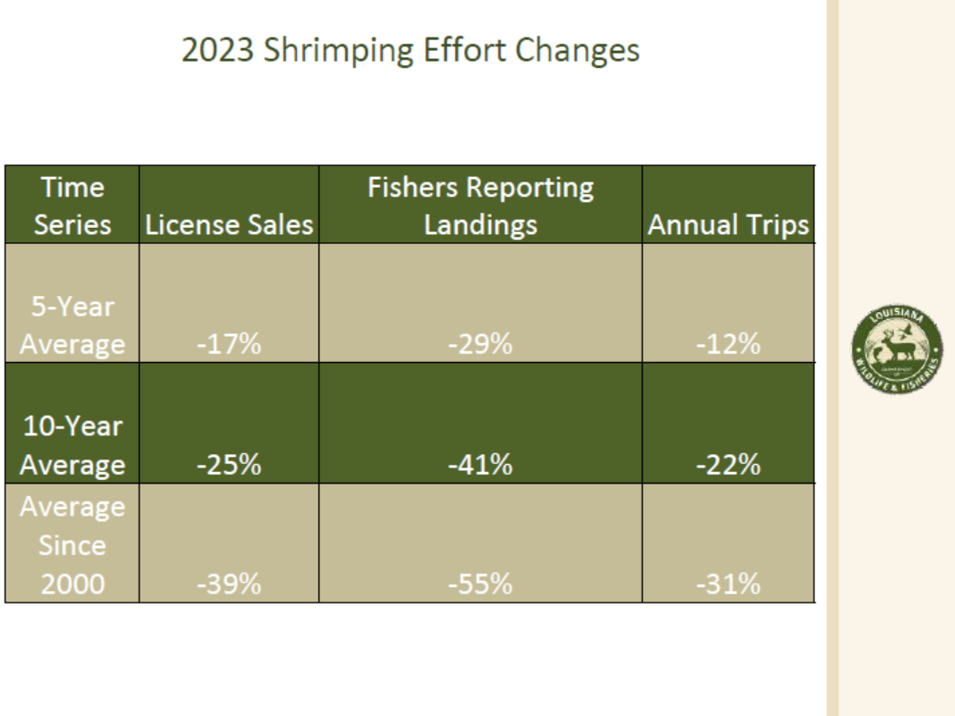

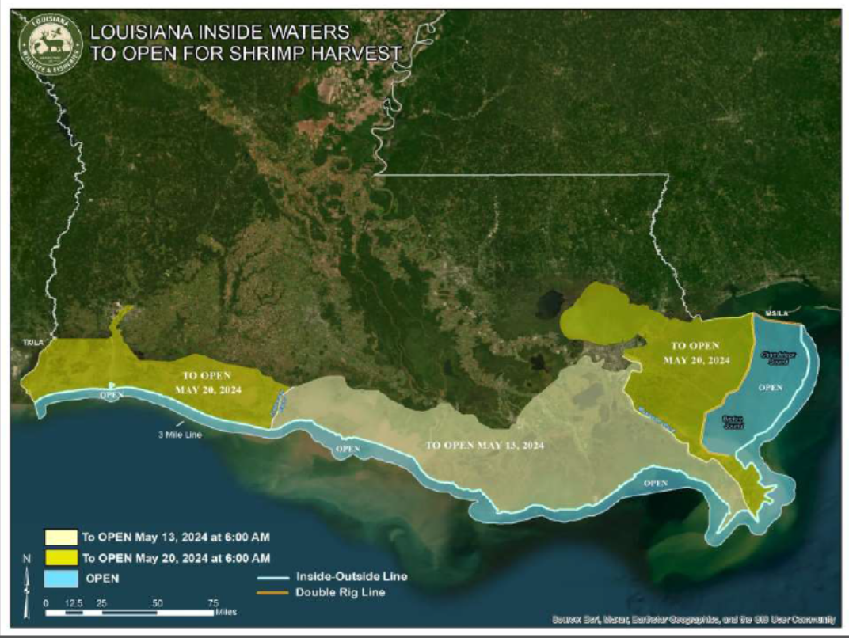

Kristen Baumer asked if Peyton was comparing to how much white shrimp is being landed during that same period of time? Peyton stated that typically they are not using this as any sort of projection, they do look at it but as far as setting this brown shrimp season this is not considered;

Acy Cooper stated that the issue with the staggered opening is the current state of the industry with the cold storage, would like to see a state-wide opening, if you open one zone the market may get flooded, problem with selling the shrimp and the shrimp they have in cold storage if they flood the market the other zone is going to be left out, would like to see an opening across the board, suggested the 16th which is the date in between the two proposed dates of the 13th and the 20th, Peyton Cagle stated that the only concern is that from a biological stand point in zone 1 and zone 3 are only going to be at 30-40% at that point in size

Rodney Olander agreed with Acy Cooper that the 16th for a state wide opening would be best

Kristen Baumer stated that he would say follow the science but doesn’t think three or four days would make a big difference

George Barisich stated that he prefers May 20th statewide opening

Dean Blanchard recommended May 20th for a statewide opening as well

Rocky Decharo stated that he would like statewide opening on May 20th

Acy Cooper motioned to statewide opening on May 16th, 2nd Lance Nacio. Motion carries with a roll call vote, all in favor

Kristen stated that he likes the 20th vs the 16th but would go with the whatever date the fishermen feel good about

C. Jack Isaacs provided feedback on imported vs domestic prices over the last 5 years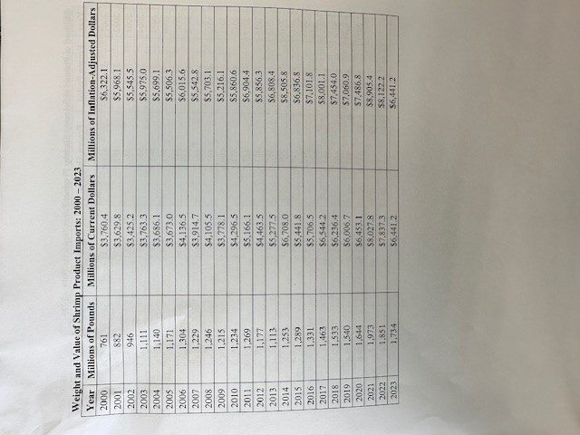
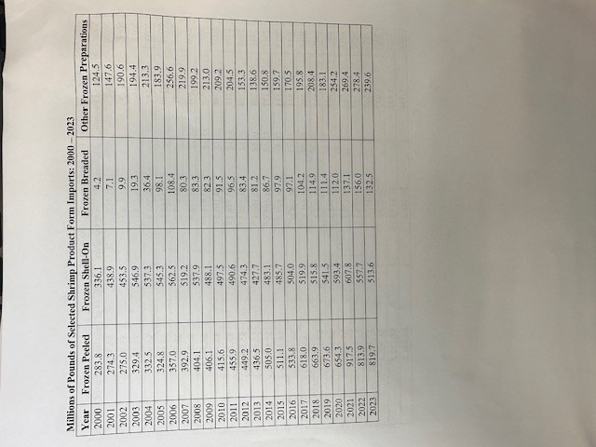

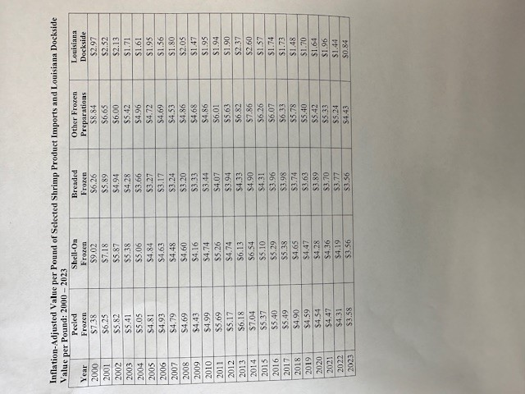

The task force stated that this issue and information needs to be presented to the Governor and the Governor needs to go to the federal government about the imports coming in

D. Jason Froeba provided an update on the 2019 Fisheries Disaster Funding

Equipment grant program- processing applications pretty slowly, the hold up was didn’t get to get to started until March, since then been increasing processing rate, last week averaging about 60 checks going out every week, submitted a report to the Secretary on April 15 detailing staffing levels and rate of processing, etc, waiting to hear back on whether or not we will be able to use department funds to increase staffing levels, target is processing about 60 applications every week, this will fluctuate depending on certain circumstances, currently have more requested than available but know there may be more ineligible and more equipment

Jason Froeba stated that LDWF is working with any vendors who will work with them on accepting payments straight to the vendor

Rodney Olander stated that if there is any way to speed up this process, the fishermen would greatly appreciate it

Earl Plaissance stated that originally it was said that you don’t have to come out of your pocket but you do have to come out of pocket

Dwane Vicknair lost some of receipts that were sent in, blew an engine in October, was able to go and get another quote on a new wheel for boat

E. Christy Fellas, NOAA Restoration Center, Jeff Gearhart, NMFS Southeast Fisheries Science Center, and Rebeccah Hazelkorn, NMFS Southeast Region provided a presentation on Reducing Juvenile Sea Turtle Bycatch through Development of Reduced Bar Spacing
Turtle Excluder Devices (TEDs)

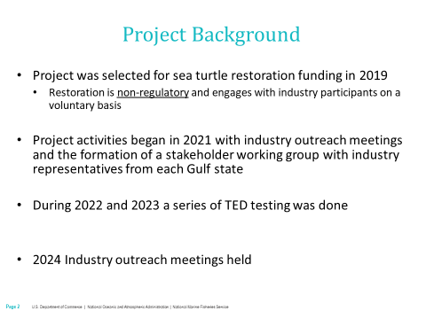
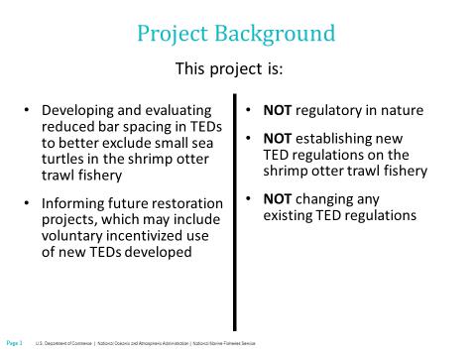
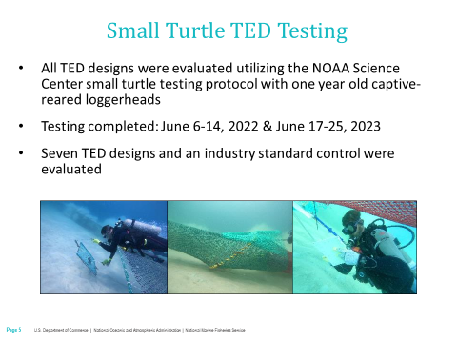
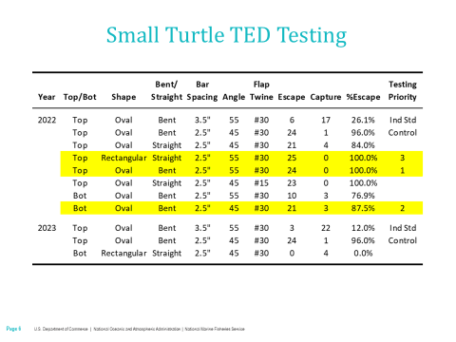
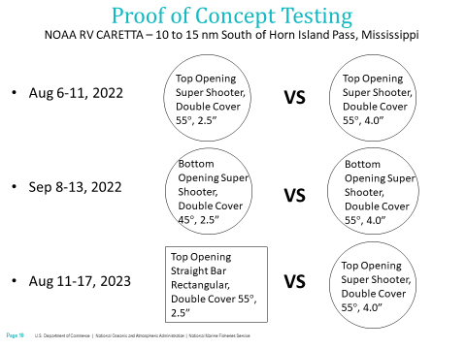
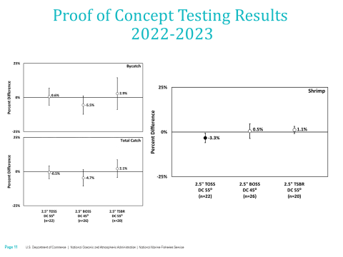
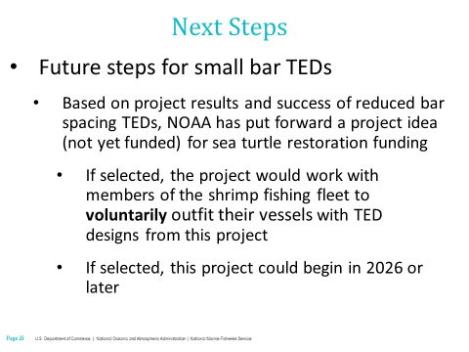
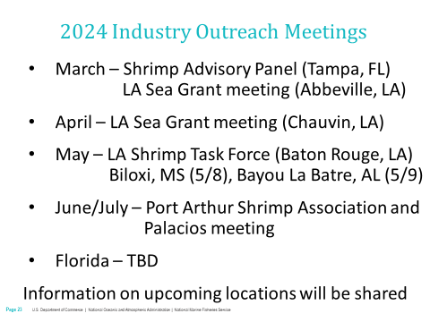

Acy Cooper, Jr. stated that the fishermen are not killing turtles, where is the point where the turtles are going to be taken off the endangered list

F. Merritt Walker provided an update on the Bycatch Reduction Project

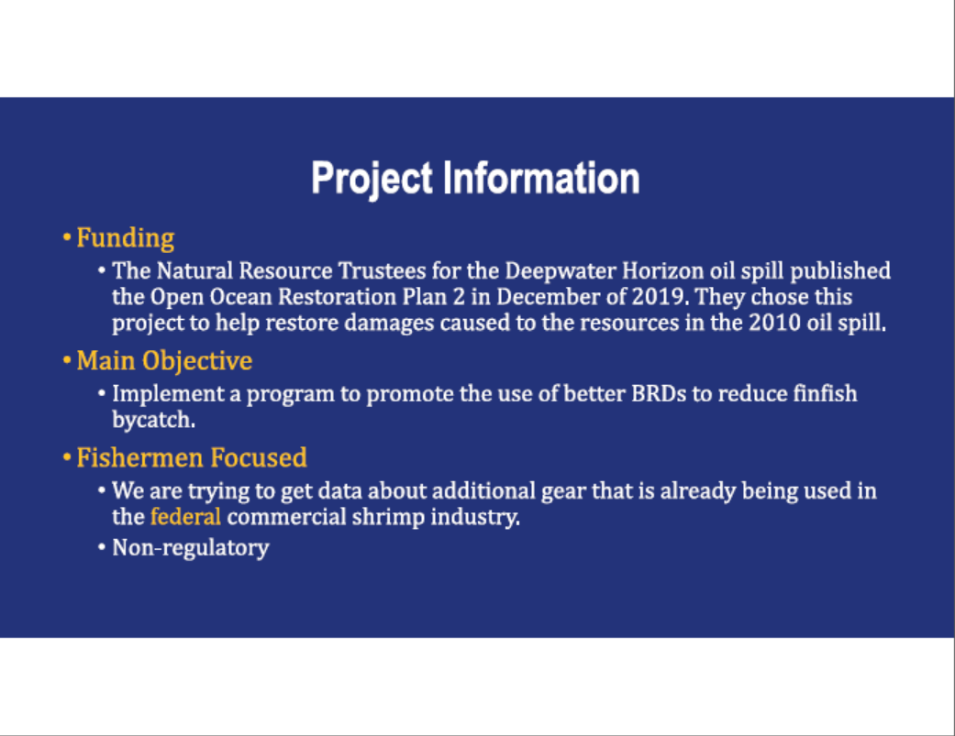

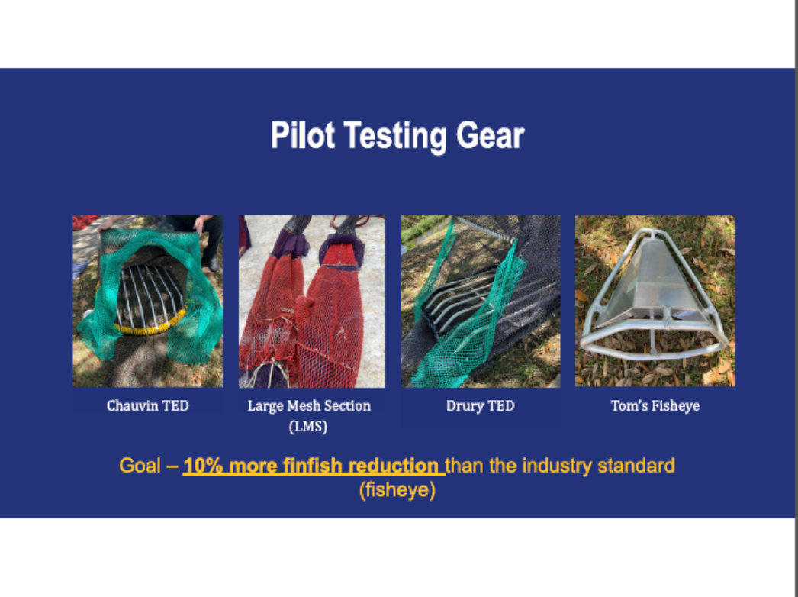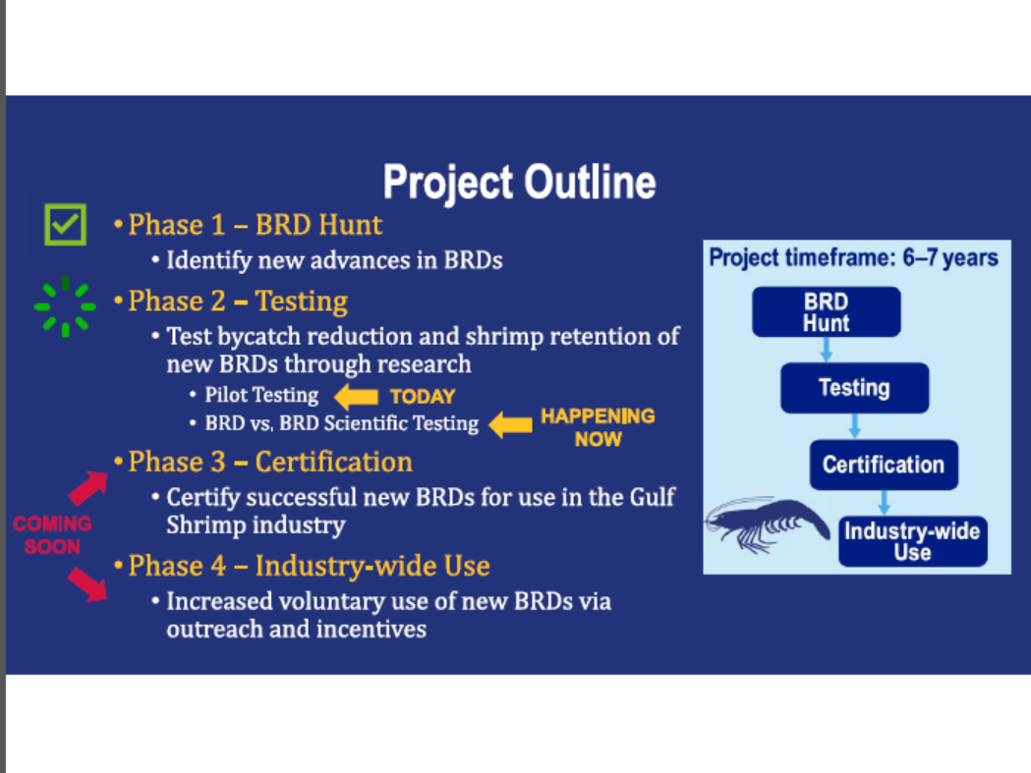
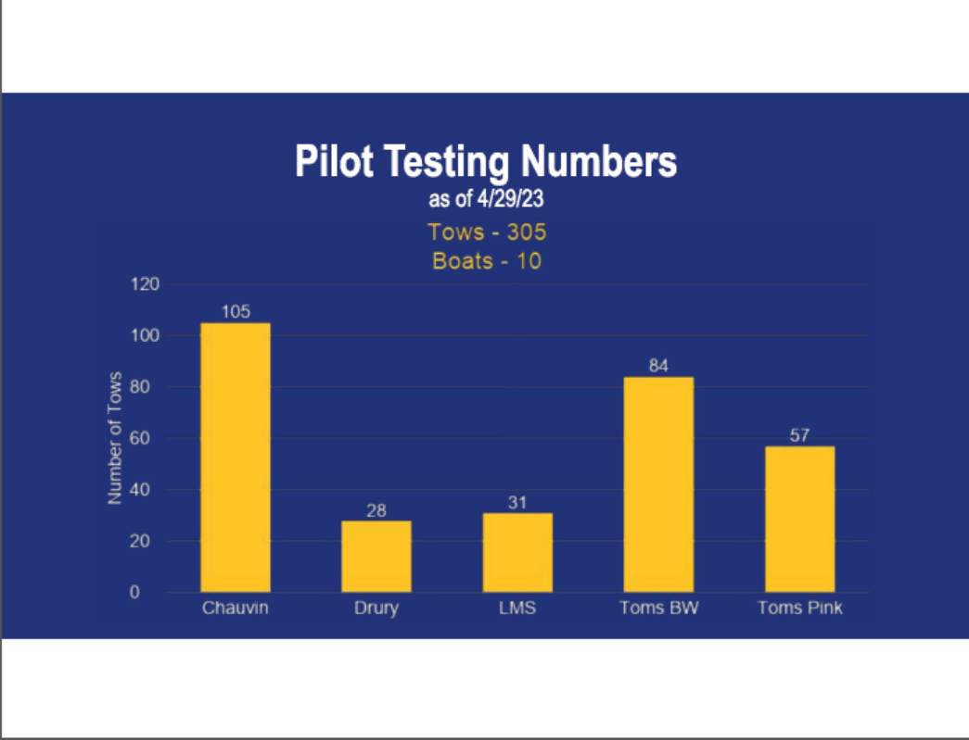
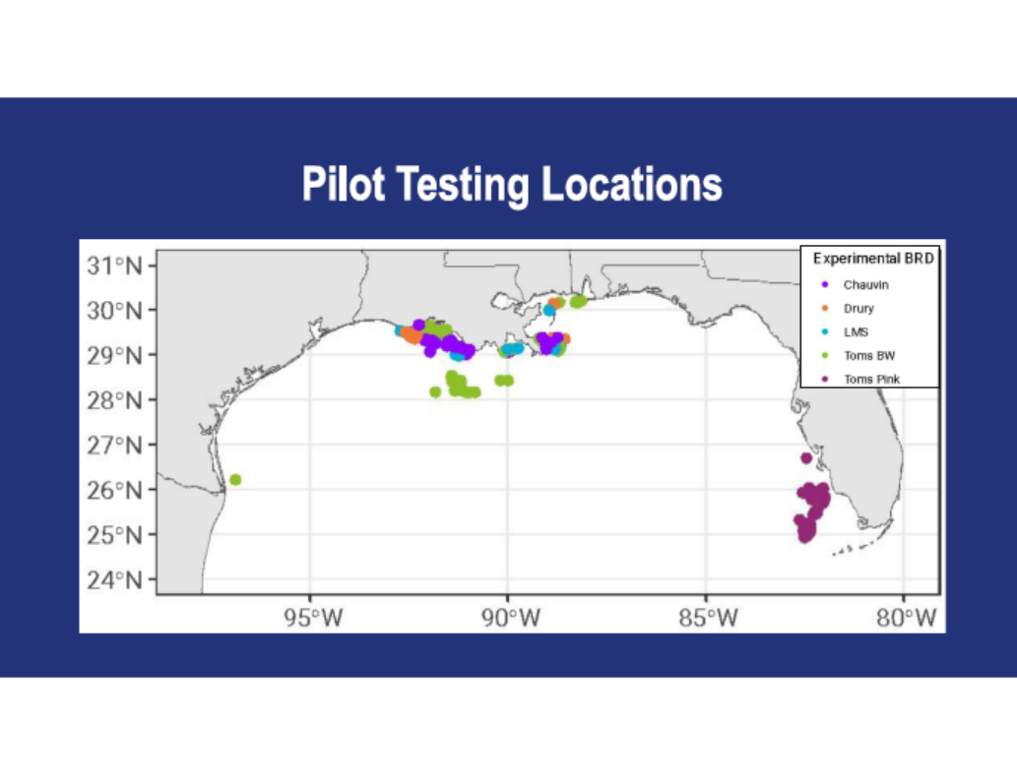
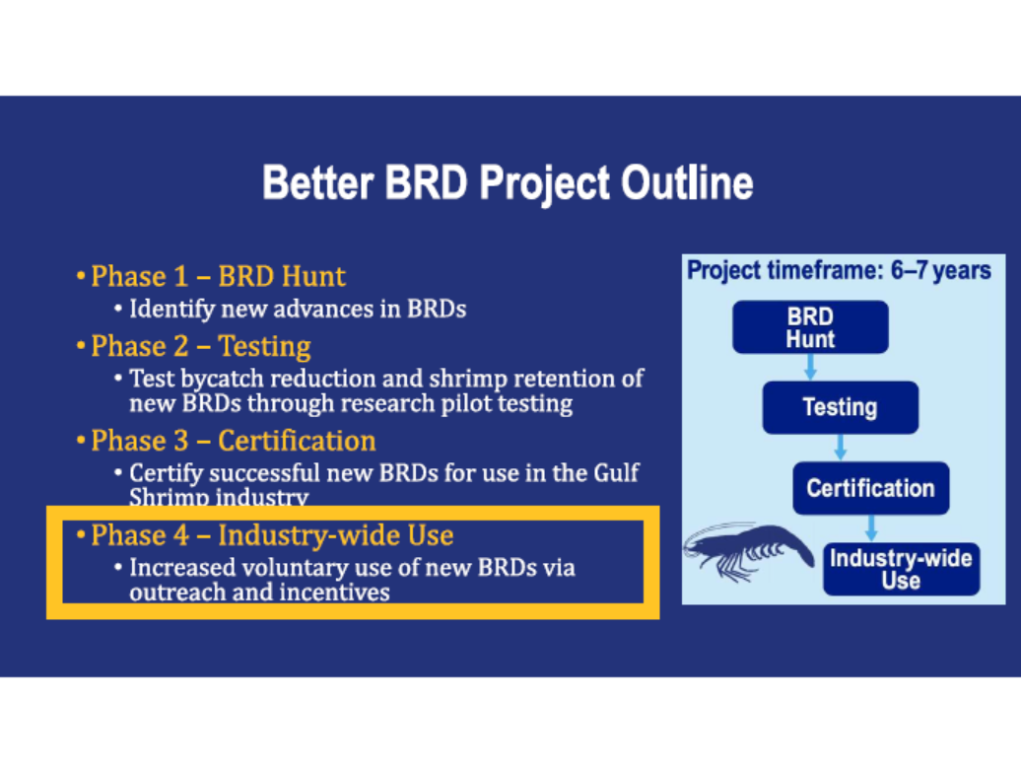
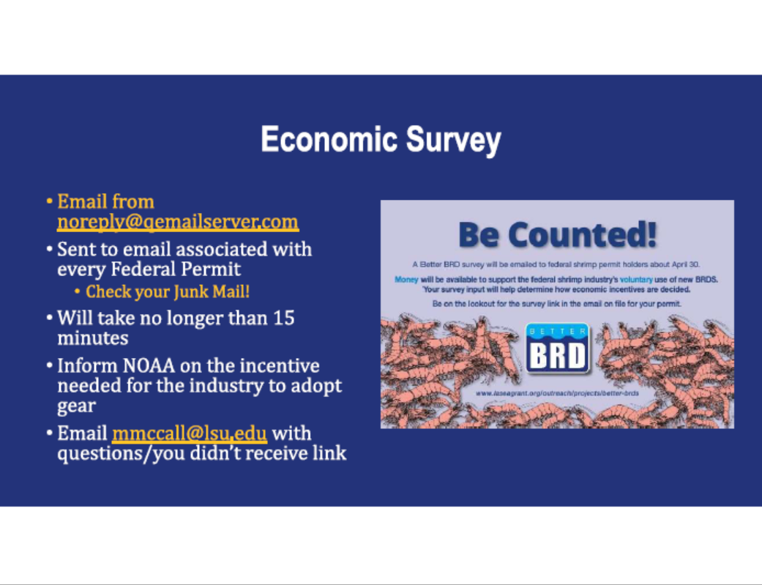

G. George Barisich led a presentation on the continued work on a documentary depicting the industry during the BP oil spill and the aftermath

Acy Cooper, Jr, motioned to write a letter of support to the Seafood Promotion and Marketing Board and CRT for the continued work on a documentary about the seafood industry depicting the BP Oil Spill and the aftermath, 2nd by Lance Nacio. Motion carries.

Gene Cavalier stated that LDAF has a LA certified program with department of Ag well over 600 LA business that go through the process just had 25 go through the process over the last month. The program has been very successful, looking for many alternatives to get LA product out there and this program has been very successful at doing that, will get the task force some more information at a future meeting but feel this would be a good program for the industry

H. The task force considered dates for task force meeting training, se the training date for July 10th in Baton Rouge 9am, the meeting venue was later moved to Houma due to meeting space availability and this training could not longer take place on this date due to the location change, the task force plans to schedule another date in the future

I. Acy Cooper led discussion on the Indian Shrimp whistleblower; stated that everything that just happened with Indian shrimp would like to get it banned here, would like to write a letter to the Governor’s office to see if this can be stopped from coming into the State of Louisiana, the issue with child labor, antibiotics, etc. this would relieve some of the issues the industry is having
Acy Cooper motioned to write a letter to the Governor to request a ban on the importation of Indian Shrimp, 2nd by Alan Gibson. Motion carries.
IX. Public Comment
David Williams with Seed Consulting stated that 2 years ago started working to develop a rapid genetic test and now have a $22 test that takes about 2 hours to process that can stop misrepresentation in the state of LA at restaurants; Acy Cooper asked that David Williams get some information together to present at the next STF meeting
X. Next meeting set for Wednesday, July 10, 2024 for 10am at the Terrebonne Parish Main Library, 151 Library Drive, Houma, LA 70360
XI. Acy Cooper, Jr. motioned to adjourn the meeting, 2nd by Lance Nacio. Motion carries.

