Shrimp Task Force Meeting
Wednesday, March 6, 2024, 10:00am
LDWF Headquarters
2000 Quail Drive
Baton Rouge, LA 70898

I. Pledge of Allegiance
II. Call to order
III. Roll call
Voting Members Present:
Rodney Olander
Acy Cooper, Jr.
Jeff Drury, III
Kristen Baumer
Alan Gibson
Andrew Blanchard
Randy Pearce

Voting Members Absent:
Lance Nacio
Phillip Tran
Chalin Delaune

Non-Voting Members Present:
Neal McMillian
Peyton Cagle
Edward Skena
Jack Isaacs
Gene Cavalier

Non-Voting Members Absent:

IV. Rodney Olander motioned to approve the August 30, 2023 meeting minutes, 2nd by Andrew Blanchard. Motion carries.

V. Kristen Baumer motioned to add an item under New Business, item G. To Hear a Presentation on Future Shrimp Projects- NOAA, 2nd by Andrew Blanchard. Motion carries.

Rodney Olander motioned to approve the agenda as amended, 2nd by Andrew Blanchard. Motion carries.

VI. The task force viewed the updated Federal Shrimp Permit report
VII. New Business
- The board discussed legal actions regarding the Department of Commerce’s Rule Requiring TEDs in skimmer trawls
Acy Cooper led discussion stating that the AG’s office went to Supreme Court with this case and it was determined that we did not have standing because a plaintiff was not involved so the case was dropped, Pelican Group approached the industry about representing them, the case was filed in federal court, currently waiting on date to go to court; at this point this is in litigation
- Cullen Curol with South Central Planning led a presentation on the Restore Louisiana Small Business Loan Program
Small Business Program Objectives:
- To assist disaster-impacted small businesses with non-construction expenses
- To aid in the recovery of small businesses and non-profits located in eligible areas that were affected by Hurricanes Laura and Delta
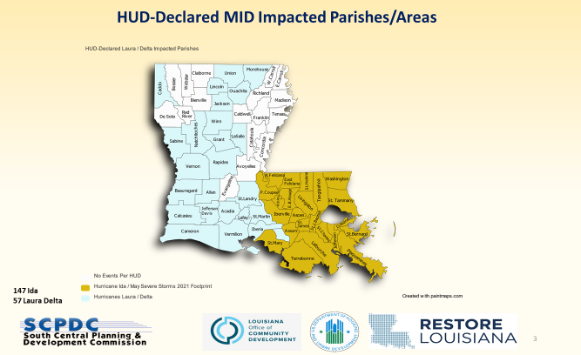
Small Business Loan Program:
ELIGIBILITY FOR SMALL BUSINESSES
To qualify for a loan, businesses must be a for-profit business or private non-profit organization and meet the following criteria:
- 1-50 full-time equivalent employees (FTE-35 hours or more per week)
- Open at the time of the disaster event (meaning the business was in operation)
- Minimum $25,000 in annual gross revenues before the disaster event *
- Must either be currently operating or demonstrate the ability to reopen upon receiving program assistance
- Experienced either
  - physical loss (minimum $10,000) OR
  - financial (20% decline)

ELIGIBLE USES OF FUNDING
- Up to six months of documented working capital expenses, which are limited to:
- Monthly rent or mortgage payments;
- Monthly non-owner employee wages and benefits;
- Monthly utilities (gas, water and/or electricity bills, phone, cable and/or internet bills);
and/or
- Inventory
2. Moveable equipment and furniture:
- Cost to replace equipment and/or furniture not yet replaced
- Cost to repair equipment and/or furniture not yet replaced
- Cost to reimburse repairs and/or replacements of equipment and/or furniture
- Cost to purchase new equipment and/or furniture necessary for the business to reopen and/or remain viable in the post-storm economy

Award Structure and Loan Terms:
LOAN TERMS
- Loan Values between $10,000 to $150,000 (with exceptions to $250,000)
- Interest rate is 0%.
- 60% of the loan will be amortized over seven (7) years, following a six-month period of no principal repayment.
- The loan is structured as 60% repayable and 40% forgivable.

Andrew Blanchard asked what happens to someone who lost their business and they are in the system, if you submit a business plan on how one can reopen. Applications taken on a case-by-case basis will try to get the money to them, asking for receipts from 2020, June 30 cut-off date but telling people April 30
Randy Pearce asked how are funds broken up between the east and the west? Cullen stated that thye are no longer accepting any more applications on the east side, Applications are processed, 27 files is between $5-6M
Rocky Decharo read a comment aloud about his experience and issues with the application process
- To Hear a presentation on future shrimp products- Matthew McPherson
Matthew McPherson provided a presentation for the task force on future shrimp products

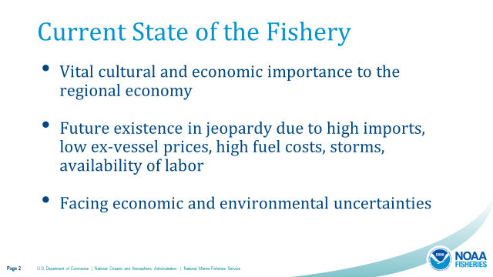
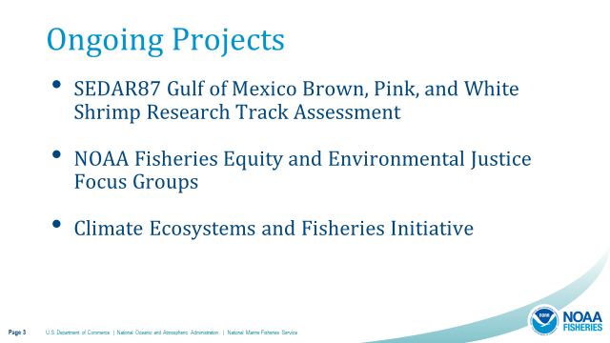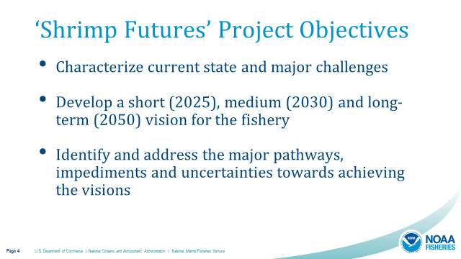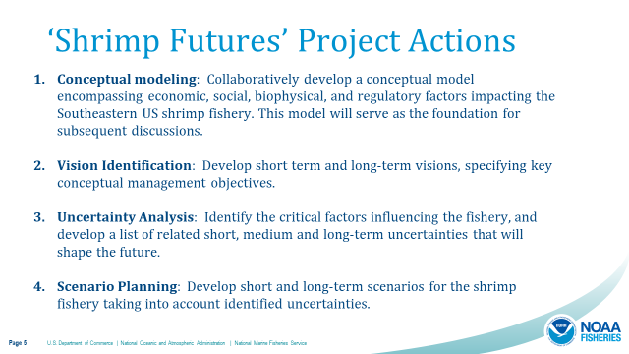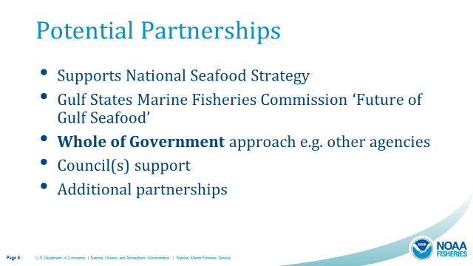
Acy Cooper stated that one of the biggest issues is the shrimp imports coming in, moving product is also an issue, cold storage
Alan Gibson stated that the government has never worked with the industry to address the pounds coming in from imports, cannot catch up to the import price and the amount coming in, more coming in than the market can consume
GSMFC organizing logistics and they should be reaching out to get the TF involved in the process
- Jason Froeba provided an update on the 2019 fisheries disaster funding
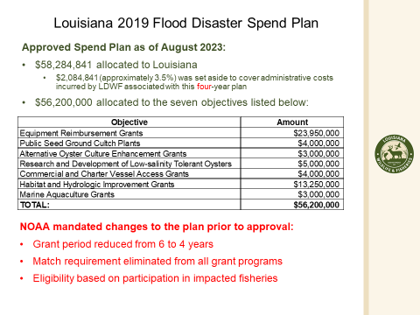

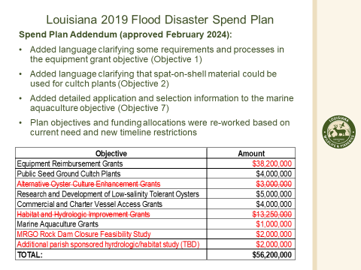
Spend Plan Implementation:
Objective 1 – Equipment Reimbursement Grants:
- Applications opened 12/5/2023
  - Administrative and review processes were still undergoing software development
  - Experienced unexpected delays due to software issues
- Test case application reviews – Late January 2024
- LDWF staff and contractors communicate daily and meet twice a week to discuss grant system, application, and policy issues
- Significant volume and variety of application issues
  - Only two out of approximately 450 applications under review have not required additional follow-up of clarification from the applicant or LDWF
- Reviewers are becoming familiar with issues and the pace of application review is increasing
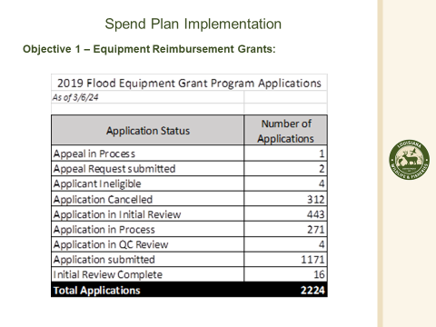
Objective 2 – Public Seed Ground Cultch Plants:
- Going through Office of State Procurement bid process
- Primary deployment site - Morgan Harbor (Three-mile Bay as a back up)
- Includes both traditional cultch and spat-on-shell material
- Deployment will be completed this calendar year (2024)
Objective 3 – Alternative Oyster Culture (AOC) Grants:
- Eliminated
Objective 4 – Research and Development of Low-salinity Tolerant Oysters:
- Ongoing research project
- Work is expected to be completed in FY 26
Objective 5 – Commercial and Charter Vessel Access Grants:
- Application period recently announced April 1, 2024 – May 15, 2024
Objective 6 – Habitat and Hydrologic Improvement Grants:
- Eliminated
Objective 7 – Marine Aquaculture Grants:
- Proposed press release and opening date under review
Objective 8 – Mississippi River Gulf Outlet Feasibility Study
- Sub-award agreement with St. Bernard Parish currently under development

Acy Cooper expressed how frustrated the industry is with how long this process has taken to get money to the industry from a disaster that happened in 2019

Jason Froeba stated that the federal approval is what has taken so long
Rocky Decharo expressed concerns with the Grant Program application process
- Nathan Putman led discussion on the early adoption of a new monitoring system to modernize shrimp effort in the Gulf of Mexico
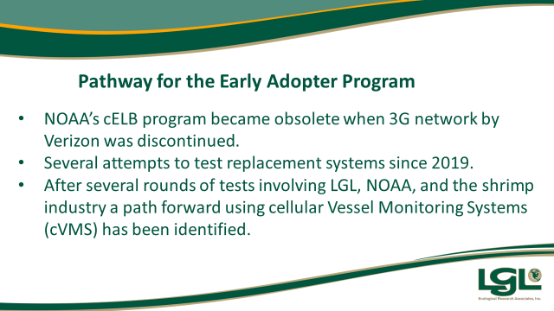
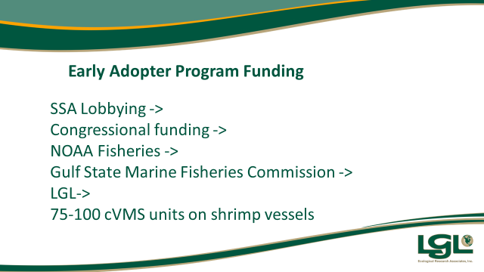
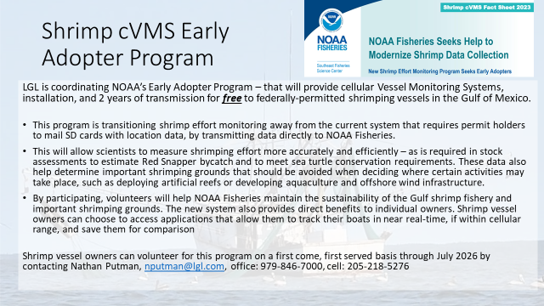
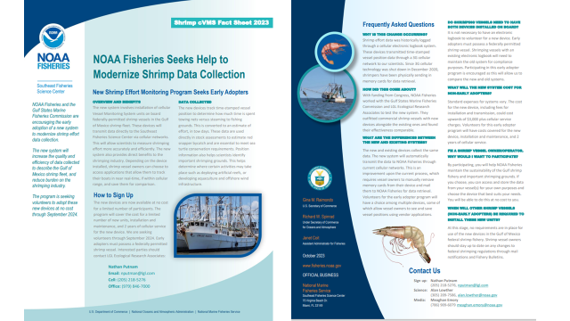
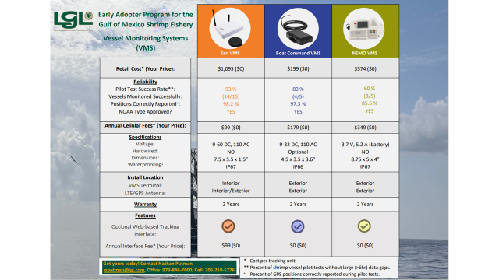
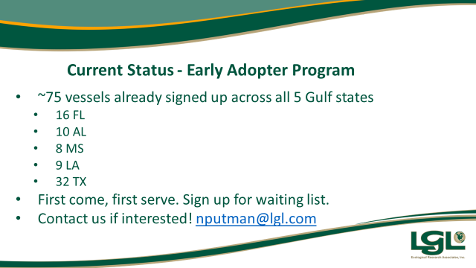
- Sara Wissmann led discussion on inshore shrimping effort to inform sea turtle restoration efforts in the Gulf of Mexico
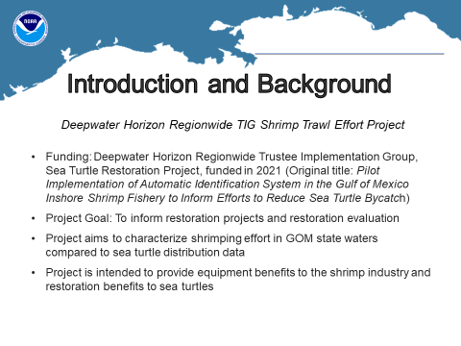
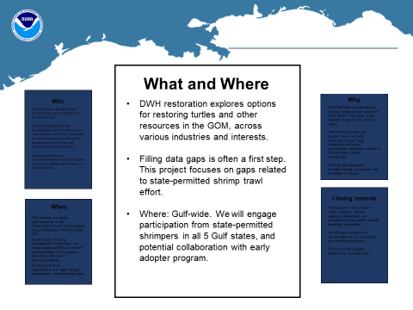
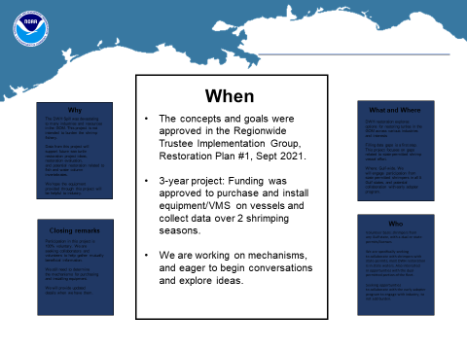
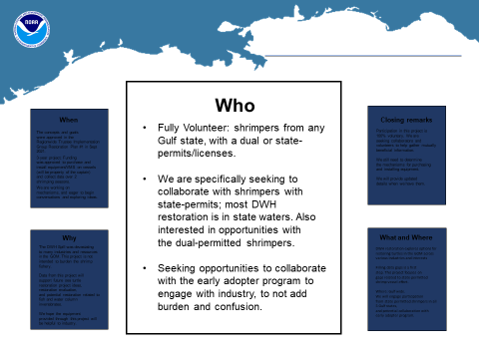
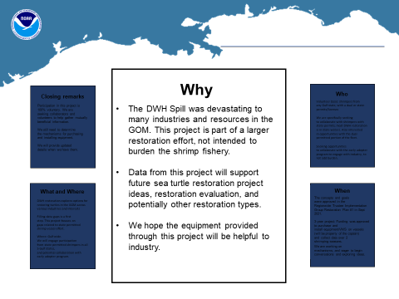
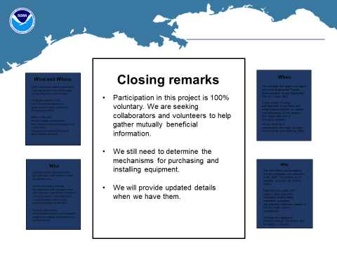
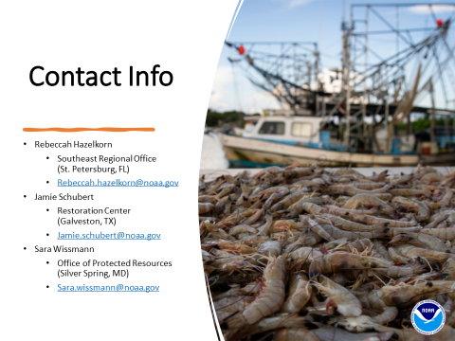
- The board discussed the STF Washington, D.C. trip
Acy Cooper led discussion, met with Senator Kennedy, Cassidy, Congressman Steve Scalise, and Congressman Garret Graves, Representative Higgins and Senator Bill Casssidy and Representative Troy Carter and discussed the TAA Program, influx of shrimp imports, import quotas, import testing
Rodney Olander added that they also discussed protein in the school system, shrimp on menus in schools all over the country, but STF added that is must be wild caught domestic shrimp, 25% reduction in imports, subsidizing the fishing, Trade Adjustment Assistance (TAA)
Alan Gibson stated that they met with the speaker of the house, it was a photo op, met with congressmen and they were receptive, feel heard,
Representative Higgins and his staff are working on a bill that would seek to get seafood in the farm bill
Rodney Olander asked for an update on any projects the Governor may be working on to assist the shrimping industry, Neal Mcmillian stated that he is going to see if he can get some feedback on this for the task force
- Gene Cavalier stated that there may be some issues that come up related to rapid genetic testing; one example can be made in Louisiana crawfish that is sent overseas and grown there and sent back here and sold as LA crawfish; this is an issue that needs to considered in this testing
- Officer elections:
Rodney Olander motioned to appoint Andrew Blanchard as the Shrimp Task Force chairman, 2nd by Acy Cooper. Motion carries.
Acy Cooper motioned to appoint Rodney Olander as vice-chairman of the Shrimp Task Force, 2nd by Andrew Blanchard. Motion carries.
VIII. Public Comment
Rocky Decharo suggested that the STF invite Congressman Garret Graves or someone from his office to attend the next meeting
IX. The next meeting set for Wednesday, May 1, 2024 for 1:00pm at the LDWF Headquarters
X. Rodney Olander motioned to adjourn the meeting, 2nd by Andrew Blanchard. Motion carries.

