Shrimp Task Force Meeting
Wednesday, March 12, 2025, 10:00am
Terrebonne Parish Council Chambers
8026 Main Street
Houma, LA

I. Pledge of Allegiance
II. Call to order
III. Roll call

Voting Members Present:
Rodney Olander
Acy Cooper, Jr.
Lance Nacio
Kristen Baumer
Alan Gibson
Andrew Blanchard
Chalin Delaune

Voting Members Absent:
Jeff Drury
Phillip Tran
Randy Pearce

Non-Voting Members Present:
Peyton Cagle
Andrew Scalisi
Davis Madere
Jack Isaacs
Gene Cavalier

Non-Voting Members Absent:
Neal McMillian

IV. Acy Cooper motioned to approve the December 18th meeting minutes as presented, 2nd by Lance Nacio. Motion carries.

V. Acy Cooper motioned to amend the agenda by adding an item under New Business, A-1. To Consider Submitting Comment to Assist in Reviewing and Identifying Unfair Trade Practices, 2nd Alan Gibson. Motion carries.

Acy Cooper motioned to accept the agenda as amended, 2nd by Alan Gibson. Motion carries.

VI. Financial Report-
Remaining Fund Balance- $589,461
Remaining Budget Balance- $88,879

VII. Federal Shrimp Permit report- the board was presented with an updated copy of the Federal Shrimp Permit Report
VIII. New Business
A-1. The task force considered sending a letter to USTR regarding unfair trade practices in the shrimp industry

Lance Nacio motioned to submit a comment regarding unfair trade practices in the shrimping industry, 2nd by Acy Cooper. Motion carries.

Acy Cooper stated that he requested an extension on the comment period as it ended on March 11, 2025, have not heard back on the approval or denial of this extension
- Sonya Self provided an update on the 2019 Equipment Grant Program
1700 applications submitted, around 85% of all applications received have either started or completed the review process, 900 applications have been paid out or approved for payment, 380 under review, a week ago a message sent out to applicants to let them know they are reaching the end of the review process and their applications may not be reviewed, some more applications may be picked up for review, right now have paid about $26M so far and based on the obligated amount and total program funding still have about $11-12M to award out through the applications that are currently in review/ additional applications that might be picked up, takes about 3 weeks to make a payment once approved for funding, average award amount about $29,000, EAG doing initial reviews of applications, however every single applications come to LDWF for a final review
- LA Department of Health provided an update on the shrimp labeling bill
Greg Richard Chief of Field Operations with LDH, provided an update on the shrimp labeling bill
Since January issued about 93 fines issued, with a $500 fine, first offense $500 and second offense is $1000, no longer providing warnings, paperclip allowance is no longer allowed have to make a permanent change, 37,000 permits throughout the state,
The Shrimp Task Force requested a report of failed businesses from LDH
Andrew Blanchard motioned to move item F. To Hear an Update on Gulf Hypoxia up and take it up now, 2nd by Acy Cooper. Motion carries.
- Doug Daigle provided an update on Gulf hypoxia and proposed a resolution for the task force to consider
Andrew Blanchard motioned to approve the resolution on Gulf Hypoxia as presented, 2nd by Lance Nacio. Motion carries.
Cheri Blanchard with SSA led discussion on the Chinese Seafood Warning Label Program
• Foreign shrimp aquaculture in countries like India and Vietnam continues to depend upon the use of banned and harmful antibiotics.
• The FDA’s routine findings of veterinary drug residues in shrimp from India and Vietnam is consistent with the findings of food regulators in Japan and the European Union, who destroy contaminated imported shrimp when found. In 2024, FDA refused the highest total amount ever of contaminated shrimp, but we simply turn it around.
• The European Union requires that the Indian shrimp industry test all shrimp before it is exported to Europe and then tests 50 percent of all shipments of Indian shrimp at the border. • In comparison, the FDA tests just 1 tenth of 1 percent of seafood import shipments for the presence of veterinary drugs (FY2015). source: the U.S. Government Accountability Office (GAO-17-443; Imported Seafood Safety p.20, Figure 3)
• In other words, an Indian shrimp processor that discovers veterinary drug residues in shrimp knows that there is a one-in-two chance that the European Union will detect it at importation versus a one-in-one thousand chance that the FDA will detect it. Those odds mean that more contaminated shrimp will be directed to this market.
• Data obtained by the Southern Shrimp Alliance through a FOIA request indicates that the FDA has found antibiotics in Indian shrimp through its sampling every year since 2009 and in 2020, 20 percent of the Vietnamese shrimp tested contained veterinary drugs.
• In comparison, the FDA has never found veterinary drugs in American shrimp, which they have sampled and tested since 2003. • The FOIA release to the Southern Shrimp Alliance also shows that the FDA tests on imported shrimp has found antibiotic-resistant disease-causing pathogens like salmonella. However, these findings are not publicly reported.
• Contaminated shrimp should not be reaching Louisiana’s families but the FDA’s failure to take strong action to address antibiotics in Indian and Vietnamese shrimp aquaculture means that this risk is very real. Last year, almost half of all the shrimp imported into the United States came from these two countries (49.2%; 755 million pounds).
• For these reasons, it is extremely important for the Louisiana Department of Health to develop a strong and accurate warning regarding the health risks associated with 1 consuming imported seafood, including imported shrimp. SSA is very willing to provide assistance with data or wording of that documentation from our research.
• It is no less important that the state provide Louisianans with this information so they may make informed choices to avoid these health risks.
• The USDA’s country-of-origin labeling laws requires retailers to provide information of where their seafood comes from, but there is no similar federal legal requirement for restaurants.
• The state of Louisiana has taken a leadership role in requiring food service establishments to provide information to their customers about where their seafood comes from, first with the 2009 law (RS 3:4734) requiring the disclosure of the country-of origin of catfish in food service establishments and then with the 2019 & 2024 laws (Act 372 & Act 148) requiring similar disclosures for shrimp and crawfish & enhancing enforcement.
• Outside of Louisiana, and now Alabama, there are no legal requirements that restaurants provide country-of-origin information to customers, the Southern Shrimp Alliance has worked with the Federal Trade Commission to combat misleading marketing of imported shrimp as domestic in restaurants. This happens when a restaurant runs advertisements that feature docks and shrimp boats or when menus list items as “Gulf Shrimp” or “Fishermen’s Catch” when what is being served is imported, farm-raised shrimp.
• Despite being against the law, restaurants routinely mislead customers as to where the shrimp they are serving comes from. The Southern Shrimp Alliance has commissioned SeaD Consulting to sample restaurants operating in the South Atlantic and Gulf of America coastline. So far, SeaD Consulting found that a high percentage of restaurants sampled misrepresented imported shrimp as domestic wild-caught shrimp. 96 percent in the Tampa/St. Petersburg area, 81 percent in Biloxi, 77 percent in Savannah, and 59 percent in Galveston/Kemah.
• At the same time, SeaD Consulting’s testing in Louisiana, commissioned by this Task Force, has found far lower rates of restaurant fraud – 33 percent in Lafayette; 29 percent in Baton Rouge; and 13 percent in New Orleans. This shows that Louisiana is on the right path. Disclosure requirements have been working in this state and have not harmed the food service industry. Improved enforcement will bring the non-compliance numbers even further down. The rest of the country is watching us. This year, legislators in Mississippi, Georgia, Texas, and Florida have considered following Louisiana’s lead with respect to shrimp and seafood. States as far away as Hawaii are also considering whether to require that seafood sellers provide more information about where their fish is coming from. 2 The Southern Shrimp Alliance is working to support efforts to improve consumer awareness of the origin of shrimp offered for sale in restaurants & retailers at both the state and federal levels. In Louisiana, that means supporting enforcement of our newly revised law, while also documenting and publicizing how Louisiana’s leadership has improved the market for our state’s shrimpers. In summary, because of the health risks to consumers by imported seafood & the decimation of our domestic industry, we cannot stress enough the importance of all hands on deck from state to federal. The results of SeaD’s testing in LA shows that LA’s leadership in state legislation has made a difference, & by clarifying risks of consuming contaminated imported seafood, will continue to make a difference, not just in our state but nationwide. The information I’ve covered may be found on SSA’s website, shrimpalliance.com including searchable databases of shrimp refusals for US, EU, Japan, and Australia. You may also refer to for latest news & to report shrimp fraud. I’ve invited my LA State Senator Mike Fesi, who co-authored the latest bill Act 148 and has been appointed to the LA Seafood Safety Task Force.
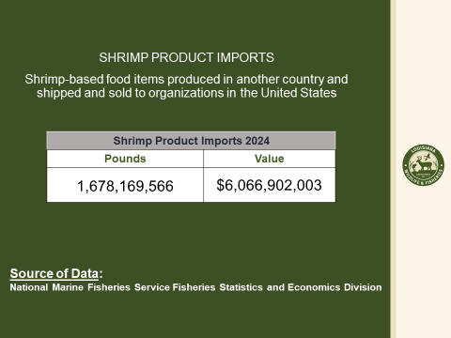
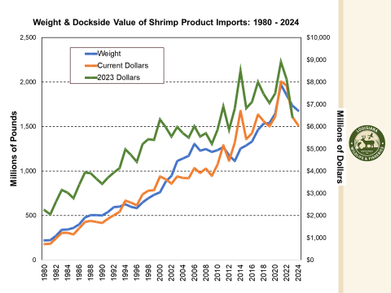
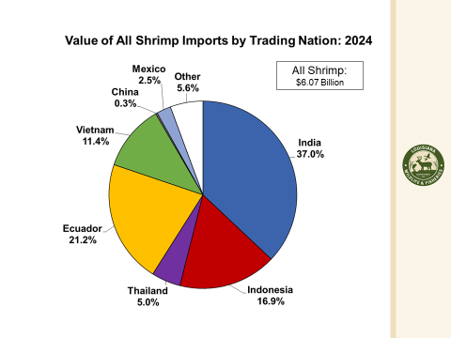
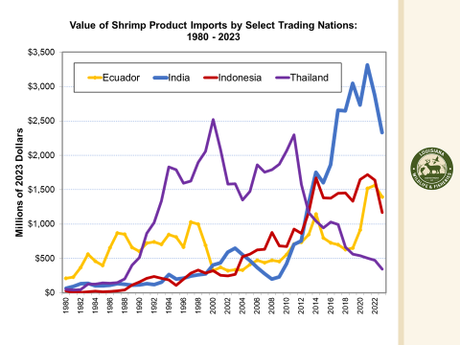
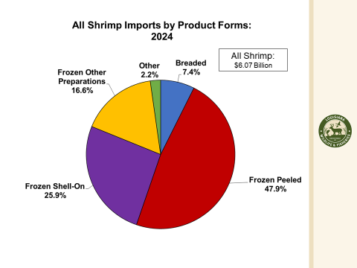
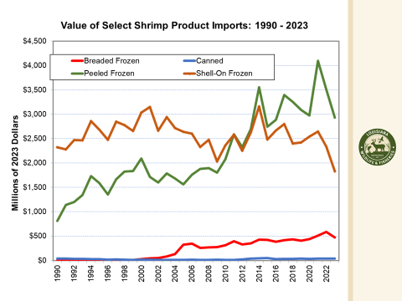
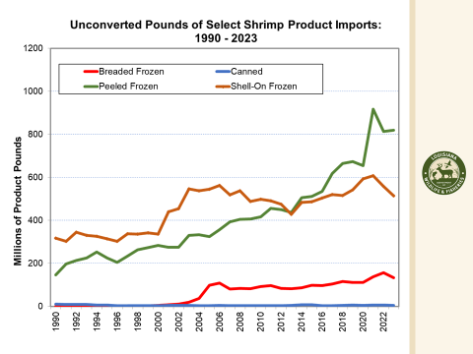
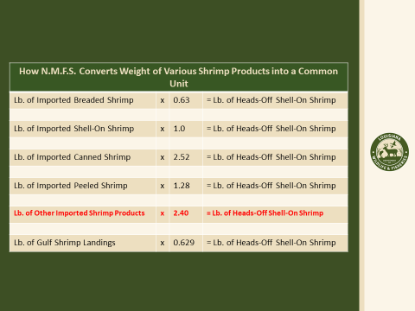
- The task force discussed rescheduling the STF Washington, D.C. trip
Acy Cooper suggested meeting with representatives when they are in Louisiana, as they will be heading home for some time, the task force decided not to reschedule their Washington, D.C. trip at this time
- Gene Cavalier provided an update on LDAF’s shrimp sampling contract
LDAF has been collecting samples and bringing them to the Ag Chemistry Lab for results, LDAF in charge of package labeling, right now LDAF has been sampling for chloramphenicol, the fluorophenicol, and the thiamine phenicol I know those were the ones that were required through law with CRT and the Seafood Promotion Board. So far there have been 59 samples, 39 have actually been completed. What we are trying to average is about 20 samples every 2 weeks, of the 59 samples 50 of them were shrimp and 9 were crawfish samples
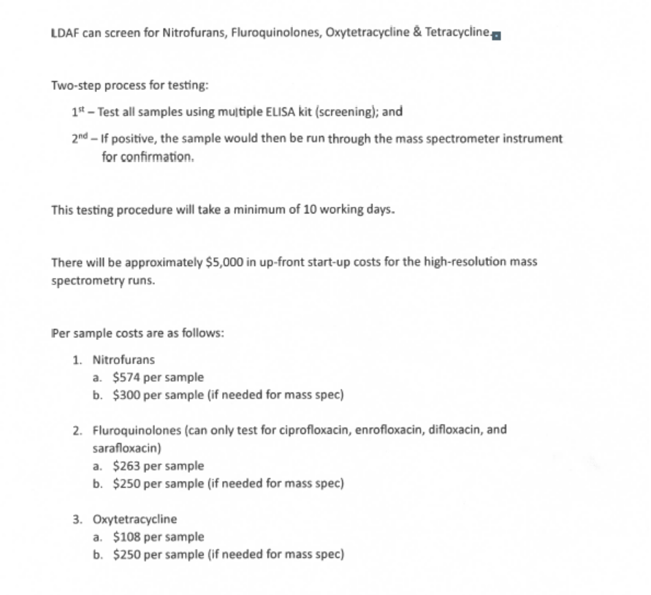
The task force was provided with the above figures to consider the cost to testing for three additional antibiotics: nitrofurans, fluoroquinolones, and oxytetracycline. Therefore, you are looking at even approximately, a $5,000 upfront startup cost to be able to have that high-resolution spectrometry of being able to be run these additional tests as mentioned in the previous document.
Alan Gibson asked if it’s possible to put all domestic/ import country of origin labeling on front of packaging, need to get labeling standardized, may need all product to be labeled the same so the customer knows where to look for the country of origin labeling
Gene Cavalier stated that LDAF put a letter out in August to let businesses know what is coming in January regarding new country of origin requirements
STF plans to request that legislators take the labeling issue up and see if they would be willing to pass something
Alan Gibson motioned that the Shrimp Task Force pursue legislation that would require ALL seafood products both domestic and imported require country of origin labeling on the front of all Louisiana packaging, 2nd by Acy Cooper. Motion carries.
Acy Cooper motioned to amend the MOU between LDWF and LDAF to include testing for three additional antibiotics, nitrofurans, fluroquinolones, and oxytetracycline, 2nd by Andrew Blanchard. Motion carries.
- David Williams provided an update on SeaD Consulting shrimp testing and contract
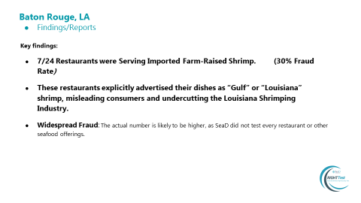
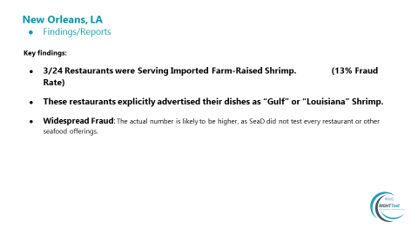
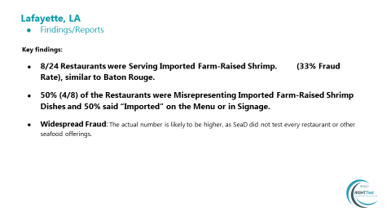
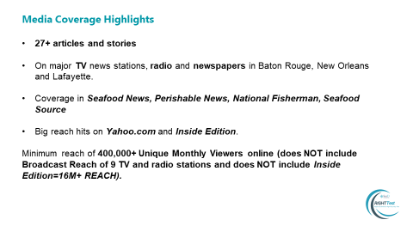
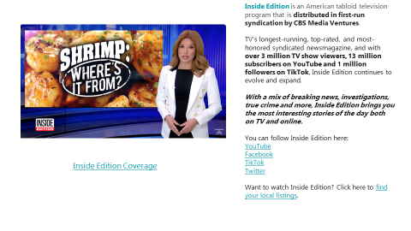
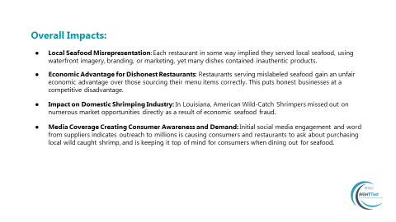
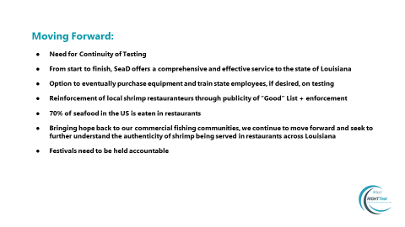
Andrew Blanchard motioned to add an agenda item to consider funding to extend the SeaD Consulting Contract, 2nd by Lance Nacio. Motion carries unanimously.
Peyton Cagle stated that you cannot exceed $75,000 per contract or you have to go out to bid, can spend $4,000, once you're under contract with a vendor cannot do it again within the same year, so wouldn’t be able to do this until December, possible other option would be to apply for sole source and if this is possible may be able to forgo the bidding process, if this would qualify under sole source then would be able to move forward and can contract
The task force requested that SSA look into sampling for Louisiana as they are doing for the other Gulf States
Task force requested for a final report of all failed restaurants when completed
The task force would look into extending the contract for an additional 4 months for $70,000; see if this would qualify under sole source
Andrew Blanchard motioned to request that LDWF look into SeaD Consulting qualifying Sole Source to extend the contract for another 4 months, 2nd Lance Nacio. Motion carries.
- The task force considered amendments to the special bait dealer’s permit
Andrew led discussion on amending the special bait dealer’s permit
Acy Cooper stated that the concern was that this would go wild and everyone would try to get into this industry, using the same rigs as everyone else, do not have an issue with this but do have an issue with the bickering back and forth and pointing fingers
Michael Guidry from Galliano, commercial fishermen have to sell to marina, have to have permit and strictly monitored with VMS systems by LDWF, target anywhere from 50/60s to 70/80s, when the season is closed the only thing we can have on the boat is live bait, swimming shrimp or croakers, the marina is the only place they can sell
Peyton Cagle stated that when a permit is issued to a land based facility, have to put that vessel under the permit, if you’re properly licensed during the open season you can sell shrimp in any disposition you want, as long as you’re licensed and doing trip tickets, if it’s a closed season can only sell directly to the permit holder
Clay Boudreaux stated that two people who do not have a brick and mortar place trailer shrimp to a licensed whole-sale dealer, with this in mind last year purchased a boat had two agents came on the boat and asked them if it would be legal to go out with a bait license, come back call LDWF, close trip ticket and the next day transfer those shrimp to whole-sale-retail license if he would be allowed then to go on the beach and sell the bait under title 76 section 4, caught shrimp under the restrictions of the title and currently under the whole-sale-resale license, seized bait license, this year go to get license and wanted to make sure that he wanted to continue to do this that he was good, legal let him know there is still some inconsistency and still some uncertainty left in the law, if you can do it out of a pickup truck why can’t you do it out of a boat, pick up tails every five minutes and anything that is not three fingers or bigger goes back overboard; the wholesale resale license needs some amending, tweak the verbiage to allow for sales from a boat that is not trawling; the wholesale retail license changes would require legislation
Peyton Cagle stated that all of this action could be done through the LDWF Commission; the language within the special bait dealer’s permit would need to be changed to state that the permit holder would be able to sell on the water
Rep Joseph Orgeron stated that he has several constituents who are live bait dealers; Commission has authority on the live bait side, stated that he is here if any legislation action is needed or to help
Peyton Cagle stated that most of the issues would be covered if you allowed the permit holder to sell on the water but keep the land-based requirement
Alan Gibson motioned to recommend that the LDWF Commission consider allowing a special bait dealer permit holder to sell their catch directly on the water, while still upholding the requirement for a land-based facility, 2nd by Lance Nacio. Motion carries.
- The task force considered funding to participate in the 2026 LA Alive event in Washington, D.C.
Andrew Blanchard motioned to fund the purchase of 10 tickets for the 2026 LA Alive event in Washington, D.C., 2nd by Chalin Delaune. Motion carries.
IX. Public Comment
Julia Falgout mentioned a clarification on the shrimp permits. Looked up the Rule 17B, it went into effect, January 22, 2018, and it sets a minimum threshold for the number of Gulf shrimp permits at 1072, and it specifies a review panel process with when or if that number gets close to being there. At the last Shrimp AP meeting, they did bring it up, so people are starting to recognize it. At the last December Shrimp AP meeting, the question was asked, how many of these permits are actually active, as of September 20, 2024 they had 1257 permits, 807 reported landings, of that 651 were offshore landings, and so our active vessels are at 807 in 2024, and so, and we've lost more vessels since then. The whole thing is going to be coming up the Gulf Council to form this group to start looking at what do they do because there is a possibility of maybe opening it back up
Rep. Joseph Orgeron Equipment Grant Program feedback was very useful, 1099G is provided anytime the government gives you money, the advice is to report it but you may not be paying any tax on this funding. Doug Daigle at the last Gulf Hypoxia meeting asked about picking up where Rep Zeringue left off with supporting the Gulf Hypoxia effort, agreed to help if needed
Andy Scalisi stated that NOAA is updating their economic study for the Gulf States Inshore Shrimp Fishery and will be mailing out questionnaire to random license holders, asked that the industry be on the lookout that this is sometimes mistaken as spam and it’s not, the last questionnaire was done in 2012
X. The next Shrimp Task Force meeting was set for Wednesday, April 30, 2025 for 10:00am at the Terrebonne Parish Council Chambers in Houma
XI. Chalin Delaune motioned to adjourn the meeting, 2nd by Kristen Baumer. Motion carries.

