Shrimp Task Force Minutes
Wednesday, December 18, 2024, 10:00am
Terrebonne Parish Council Chambers
8026 Main Street, Houma, LA

I. Pledge of Allegiance
II. Call to order
III. Roll call and introduction of guests
Voting Members Present:
Rodney Olander
Alan Gibson
Andrew Blanchard
Randy Pearce

Voting Members Absent:
Acy Cooper, Jr.
Lance Nacio
Jeff Drury
Phillip Tran
Kristen Baumer
Chalin Delaune

Non-Voting Members Present:
Neal McMillian
Peyton Cagle
Jack Isaacs
Gene Cavalier

Non-Voting Members Absent:
Davis Madere

IV. Rodney Olander motioned to approve the October 9, 2024 meeting minutes, 2nd by Randy Pearce. Motion carries.
V. Rodney Olander motioned to amend the agenda by adding an item under New Business, “H. To Consider Amendments to the Special Bait Dealers Permit Regulations”, and to move item D to item A., 2nd by Randy Pearce. Motion carries.
Rodney Olander Motioned to add, “IX. Public Comment”, to the agenda, 2nd by Randy Pearce. Motion carries.
Rodney Olander motioned to adopt the agenda as amended, 2nd by Alan Gibson. Motion carries.
VI. Financial Report:
Remaining Fund Balance- $618,866
Remaining Budget Balance- $143,498

Rodney Olander motioned to accept the Financial Report as presented, 2nd by Randy Pearce. Motion carries.
VII. The task force heard an update on the Federal Shrimp Permit Report

VIII. New Business
- Gene Cavalier led discussion on re-appropriating STF funding for shrimp testing to the Department of Ag and Forestry
Rodney Olander motioned to re-appropriate the funding that was slated for shrimp testing, originally sent to LA Department of Health, to the LA Department of Ag and Forestry for $50,000, 2nd by Alan Gibson. Motion carries.
- Mike McDonough provided a presentation on the East Cameron 346 Special Artificial Reef Site
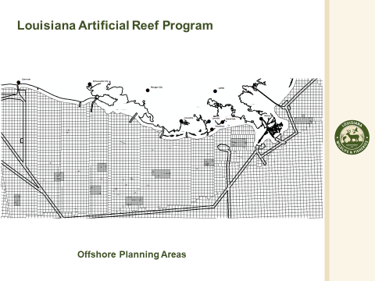
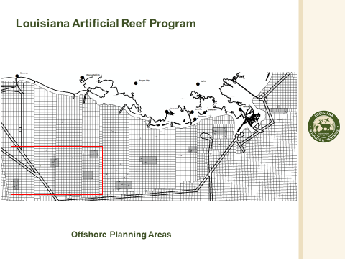
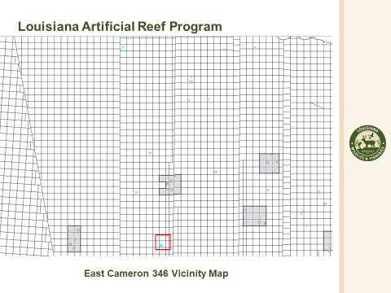
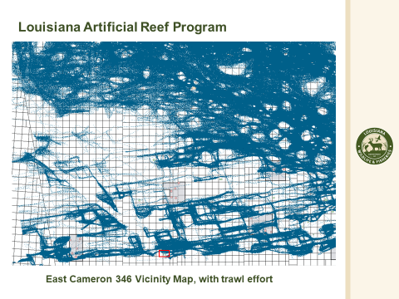
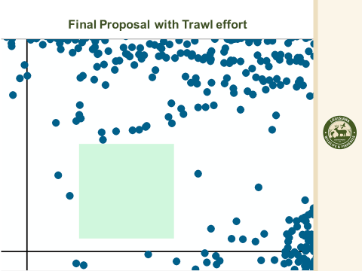

- Jason Froeba provided an update on the Equipment Grant Program

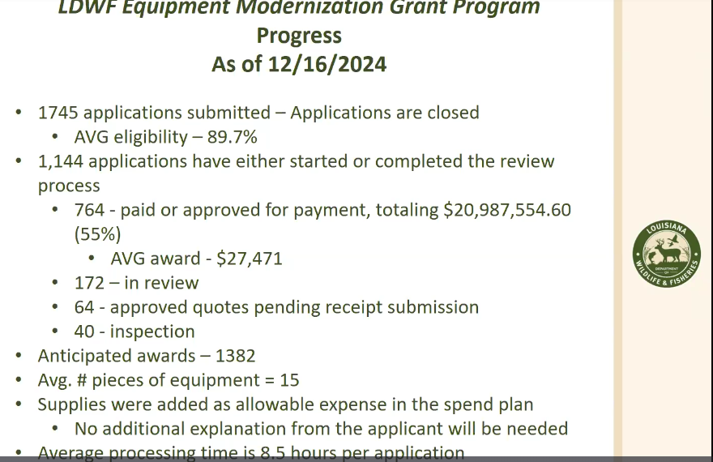
Supplies were added as allowable expenses in the spend plan
- The task force tabled item, “D. To Consider Writing a Letter of Support for a Grant Proposal, “Enhancing Louisiana Shrimp Market Demand: A Sustainable Approach to Premium Quality with Natural Solutions” until the next meeting when Dr. Sathivel can attend
- David Williams provided an update on SeaD Consulting’s shrimp testing
David Williams explained the sampling process, stating that they took the Baton Rouge area, used records including those from the Health Department and search engines, selected a large number of restaurants, and used a random number-generating program to drop it down to the 22 restaurants that were sampled. When visiting a restaurant that is going to be sampled they looked at the outside and inside of the restaurant, looked at the menu items, what we tried to do is if we saw somebody ordering something in front of us. We tried ordering the same item so that we were not biased. We take a sample, take a picture of the menu, we take a picture of the product presented to us. We take a picture of the product going into the container. We numerate that container, then we freeze it down, and then we take it back and test it. In this circumstance, we used Florida State University because they have been involved in a lot of sampling, and we did not have the capacity to do it ourselves. Took 22 samples and nearly every single restaurant did not comply with any form of labeling. Out of the 22 samples, there were six samples that were imported farm raised shrimp and it was not indicated on the restaurant, though by the restaurant those were imported shrimp. Therefore, out of 22, we have six samples that were incorrectly labeled, which is just a little bit under 30%. The future law coming up needs to be implemented and the only way it can really be implemented is by testing of the product on the plate
David Williams stated that they have a bunch of news organizations that this information is distributed to, can add to distribution list, can target specific areas, will get TV coverage around the state across the coast, if anyone has a good contact asked that they pass on that information
Rodney Olander motioned to move item, G. To Consider Appointing a LA Shrimp Task Force Representative to Approve SeaD Consulting Contract and Payments” up on the agenda and take up that item at this point on the agenda, 2nd by Alan Gibson. Motion carries.
- The task force considered appointing a LSTF representative to approve SeaD Consulting contract and payments
Need 1-2 liaisons from TF to approve press releases
Rodney Olander motioned to appoint Andrew Blanchard and Rodney Olander to serve as the representatives to approve the invoices and press releases for SeaD Consulting, 2nd by Randy Pearce. Motion carries.
- The board heard an update from the International Trade Commission meeting
Putting tariffs on shrimp, lawsuit on ITC, needed shrimp input, ITC voted in shrimp industry’s favor
Andy Gibson stated that the case originated by ASPA on behalf of the industry, it’s an open trade case, it’s been completed, was successful in generating in excess of $3M to the general fund, hope that with new admin in D.C. will help find ways to get the money back to the industry, quota needs to be addressed still, the answer that needs to be addressed is a quota on shrimp imports
Rodney Olander stated that the task force asked for a 25% reduction in imports in D.C. but the % can fluctuate depending on consumption and supply
- The task force considered amendments to the Special Bait Dealer Permit Regulations
- Clay Boudreaux from Lake Hermitage, lower Plaquemines Parish, would like to discuss the Live Bait Shrimp Dealers Permit, Stated that he presently holds all the permits and licenses at the Department of Wildlife and Fisheries Office that are required for business. Started my business in 1999, this coming year makes 26 years that I've been operating a fishing lodge in a marina down in Plaquemines Parish. Beginning of this year, I asked two local agents to come on my boat, and I told them what I wanted to do. They looked at my permits. We had a discussion, and they told me that I was legal to sell the live shrimp off my bait boat. The way I've been doing it is that I catch the live shrimp with my bait license, I bring them home, put them in my brick and mortar tank, then call Baton Rouge and tell them that I'm back from trawling. I transfer ownership of the shrimp from my bait license to the wholesale retail license. This year there was an opportunity for me to go anchor down in Barataria Bay and sell to the fishermen. Tarpon Rodeo weekend, a big weekend, two agents boarded my boat, I gave them my license, and they said that I was violating the Title 76, section 4, of the bait license. Now I did not have the frames or the nets on my boat, because I have a hydraulic system. I have a monorail system that I take my frames off for me to cross the bay. I said, Sir, I'm not violating the Title 76, section 4, because I don't even have nets on my boat, I said I'm operating under my wholesale retail license. He asked his partner what he thought. They pushed off from my boat. They called their captain. He came back to my boat, read me my Miranda rights, seized my bait license, and wrote me a class 4 citation. I went home, called the two agents that told me it was okay to do what I was doing, and they said that they would take care of it. They came to Baton Rouge the following week, had a discussion. A few days after that a lieutenant called me up and told me to void the ticket, but he said that there was still some discrepancy and interpretation in the law on this that would need to be cleared up. I'm here today to ask, is there any way possible that we can, if the task force approves of me selling live shrimp to the fishermen off my boat during a closed shrimp season, what would be the path forward?
Peyton Cagle stated that one of the major requirements for getting a bait permit is having a land-based facility. The vessel that fishes is fishing underneath the license of the land-based facility. So that's the difference between a Fresh Products and Bait Permit, because I may own the land facility and have someone else fishing for me, rather than you're fishing your catch and selling it. The stipulation of not selling catch on the water was to make sure that basically everything was being done legally that your you're not selling your own catch, although you're catching it. You're fishing under this other license, which is the bait license. Therefore, that is kind of the separation between the two. The bait permit gives you the ability to fish during closed season.
Andrew Blanchard stated that he will put it on the LDWF Commission agenda and see when we can get it on the agenda to be addressed, may not be in January may be in February at least for discussion at the Commission level
Rocky Decharo stated that brought up the this topic at a previous meeting, this may do more damage if allowed to sell on the water
Rodney Olander stated that a land-based business should still be a requirement but would like to look into the possibility of adding the stipulation of selling off the boat
- The task force discussed STF Hill meetings for Washington, D.C. trip
- The task force considered funding for billboard advertisements in conjunction with LDAF
Gene Cavalier stated that public relations at LDAF said they could get some figures for billboards and see if a staff member can come to a future meeting to go over this with the task force and discuss options
- Officer elections
Rodney Olander motioned to open the floor for officer elections, 2nd by Alan Gibson. Motion carries.
Alan Gibson motioned to elect Rodney Olander as the STF chairman, 2nd by Randy Pearce. Motion carries.
Rodney Olander motioned to elect Andrew Blanchard as the STF vice-chair, 2nd by Randy Pearce. Motion carries.
IX. Public Comment:
Peyton Cagle stated the shrimp AP meeting that took place on Monday they provided information on observer data specifically for the small tooth sawfish and manta ray.

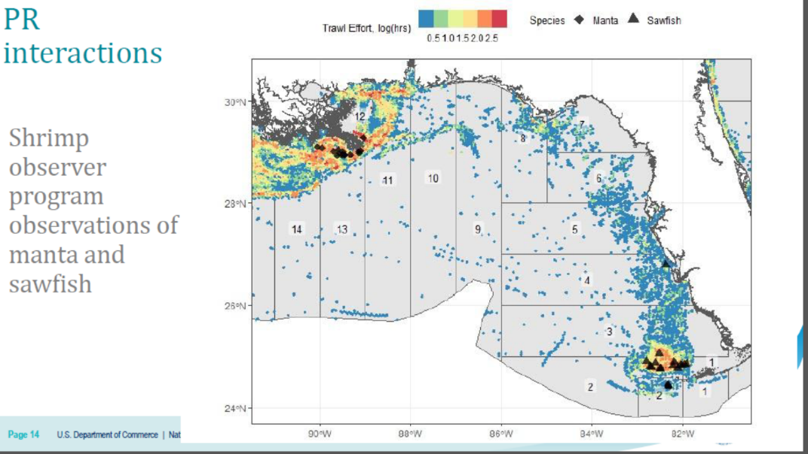

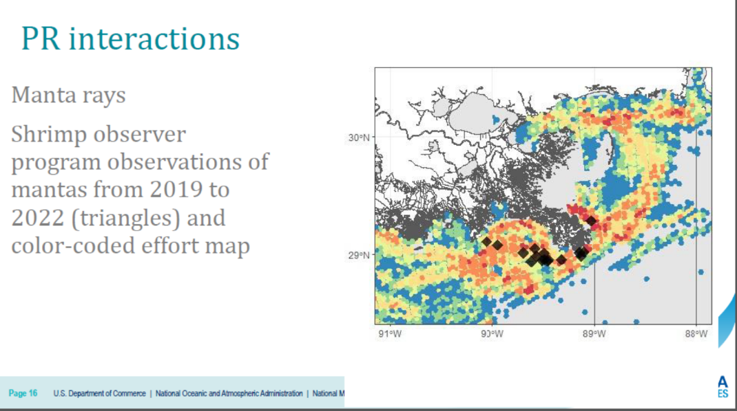
The Davis Pond Advisory Committee met this month and we have STF representation on that Committee, two representatives, no one attended, trying to stress that we have seats for the industry on that committee and it’s important to be present to voice concerns on the operation of Davis Pond. Looking for a couple of additional people to fill in as well.
Peyton Cagle stated that he took a new position within the LDWF, will remain as the STF biologist but eventually there will be a new crustacean biologist
Rocky Decharo stated that ITC will have a new opportunity with new admin, need to devote time to people who can help in D.C. when the STF is up there, please don’t miss this opportunity may not have another one
Rep Joseph Orgeron, District 54 representative, Lafourche Parish stated that he came to the meeting primarily to talk about the Bait Permit issue, also wanted to make some comments on some other items while here; received comments from constituents about the Grant Program stating that they were having issues with how long it was taking for their applications to be processed; Gene Cavalier mentioned getting money and working on new law changes for shrimp testing, Rep Domangue is willing to take on issues that need to be changed in legislation next session on the shrimp testing laws and changes, the next session is a fiscal session, start testing now to work kinks; Rep. Higgins actions with the GAO, opportunity is here, pressing on the GAO, hopefully Ecuador for shrimp and Venezuela for crab meat would be two countries that if they are hurting us economically there should not be any aid going that way, and lastly got a couple of calls about the live bait issue, Once upon a time the live bait license was written such that you had to use smaller than regulation size netting, and then they subsequently went to regular size nettings with sunsets, and that had gone through a couple of sunset periods. I ran the amendment to basically take that sun setting out and make it so that regular regulation size nets can be used for live bait license and catching. In doing that, I kind of studied and went through the law and really thought whenever this original live bait license legislation was written, they covered all bases. It had everything covered from the $1,000 bonding to the land based retail location, the checking in checking out nighttime VMS, tracking. You think you read the law, and it covers all bases, and then you start getting calls about issues and you start realizing there is a lot of a lot of fluffiness around the edges that that need to be tightened up, so I had heard about. Mr. Boudreaux. Some additional issues are people who have brick and mortar bait shops, and the $1,000 bonded live bait license during close season, going out during close seasons and inside water, catching live bait, bringing it to their bait shop, selling some of it there, taking the rest of it, putting it back in their boat, not operating under the live bait license, but just to transport it to people's camps, waterfront camps that have live bait wells. So now, you're doing a premium secondary service of retail, where you deliver to the camp and put it in their live bait wells. Many scenarios need to be discussed and recognize that something needs to be done and discussing whether or not legislation is needed. Not locked up on all my 5 bills yet this upcoming session and am willing to help if needed.
X. The next meeting set for Wednesday, March 12, 2025 for 10:00am in Houma at the Terrebonne Parish Council
XI. Rodney Olander motioned to adjourn, 2nd by Randy Pearce. Motion carries.

