LA Shrimp Task Force Minutes
Wednesday, October 9, 2024, 10:00am
Terrebonne Parish Council Chambers
8026 Main Street, Houma, LA
I. Pledge of Allegiance
II. Call to order
III. Roll call
Voting Members Present:
Acy Cooper, Jr.
Lance Nacio
Jeff Drury
Kristen Baumer
Andrew Blanchard
Randy Pearce

Voting Members Absent:
Rodney Olander
Phillip Tran
Alan Gibson
Chalin Delaune

Non-Voting Members Present:
Neal McMillian
Peyton Cagle
Davis Madere
Jack Isaacs
Gene Cavalier

Non-Voting Members Absent:

IV. Acy Cooper motioned to approve the July 31, 2024 meeting minutes, 2nd by Kristen Baumer. Motion carries.

V. Acy Cooper motioned to add an item to the agenda under New Business, item F. To Consider Funding for Shrimp Task Force travel to the International Trade Commission Meeting, 2nd by Kristen Baumer. Motion carries.

Acy Cooper motioned to approve the October 9, 2024 meeting agenda as amended, 2nd Kristen Baumer. Motion carries.

VI. Financial Report
Remaining Fund Balance- $687,843
Remaining Budget Balance- $220,331

Acy Cooper motioned to approve the financial report as presented, 2nd by Lance Nacio. Motion carries.

VII. The board reviewed the updated Federal Shrimp Permit Report

VIII. New Business:

- Coby Sammis, Legislative Assistant to Congressman Higgins, provided some feedback on the Protect American Fisheries Act
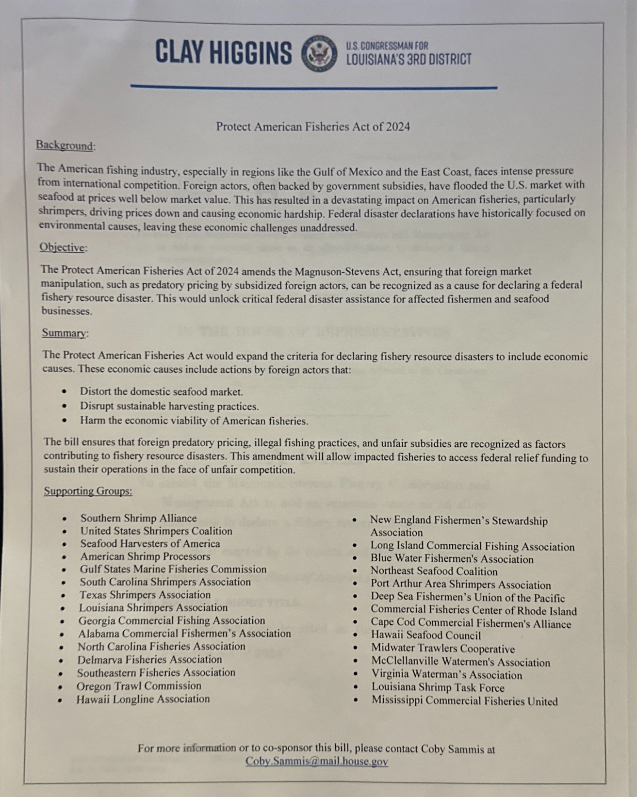

Kristen Baumer asked who makes the determination on whether there is damage due to dumping? Mr. Sammis stated that Natural Resources is considering adding this to the bill, basically once these investigations are done it would trigger a disaster and allow for financial assistance

Andrew Blanchard asked what is the timeline? Mr. Sammis stated that it’s not introduced just yet, closed co-sponsorships on October 4th and looking at introduction sometime this month or early November, once introduced would then have to convince the committee of jurisdiction
- Coby Sammis Provided an update on the Save Our Shrimpers Act, 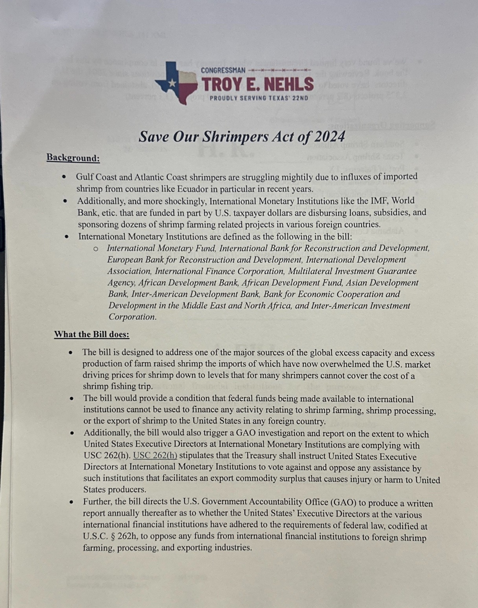
Kristen Baumer stated that inspection percentages are really low, what we did in LA was pass a country of origin labeling bill, allows consumers to be on notice of what they are eating, may want to look into a national HR1057 imported seafood Safety Standards Act, increase inspection rates for FDA and increase labeling, if shipment is rejected all other ports of entry will be notified
- The Task Force discussed appropriating Shrimp Task Force funding for shrimp testing. Peyton Cagle provided some background, in 2023 the task force motioned to dedicate $50,000 LDH to improve testing on shrimp, new legislation that took place moved testing from LDH to LDAF and CRT, since the bill passed LDH is not taking the money
Peyton Cagle recommended that the task force hold onto the funding until all the agreements go through and are set in stone to take action on appropriating the money
Acy Cooper discussed having a meeting with department heads asked Gene Cavalier to set this meeting up, (Mike Strain, LDH and CRT)
- David Willians with SeaD Consulting led discussion on shrimp testing
Overview
SeaD Consulting proposes a monthly restaurant testing program designed to ensure accurate seafood labeling for restaurants across the coastal region. Our goal is to provide transparency and accountability for seafood sourcing, protecting both consumers and businesses from fraudulent or mislabeled seafood products.
This proposal outlines a comprehensive testing initiative with monthly visits to 24 restaurants. Our program includes the use of control samples (one known negative and one known positive per testing cycle) to ensure test accuracy. All collected samples will be stored in a low-temperature freezer, with the option for secondary testing if necessary.
With a data size of nearly 300 tests annually, this program offers a compelling opportunity to gather critical insights on seafood fraud and deception, making it an invaluable resource for the LSA in targeted market areas. The frequency of sampling, as proposed, will provide the most reliable data and is key to identifying trends and mitigating potential risks in the marketplace.

Proposal Breakdown: Scenario - 24 Restaurants, once a Month
- Monthly Fee: $17,760
This fee covers all aspects of the testing program, including labor, travel, testing, sample purchases, media/communications, and administrative overhead. The breakdown is as follows:
  - Testing Costs: $550/month
  - Sample Purchases: $480/month
  - Labor Costs: $500/month
  - Per Diem Travel Fees: $3,000/month
  - Media & Communications: $5,000/month
  - Equipment Usage Fee: $230/month
  - Management Fee: $8,000/month

Services Included
- Labor & Sample Collection: Dedicated staff will visit restaurants once a month to collect seafood samples.
- Travel & Per Diem: Travel expenses are factored in to cover the geographical scope of this initiative. Hotel/car rentals and airfare will be billed as needed.
- Testing & Reporting: Comprehensive testing for seafood authenticity, including the use of known controls, with results reported to the association.
- Media & Communications: Regular reporting and communication with key stakeholders, as well as media outreach as necessary.
- Management & Administration: Ongoing management of the testing program, including equipment usage, administrative tasks, and relationship management with restaurants and the association.

Term
Because of the infrastructure setup the minimum term is five months after one year the program will be evaluated to consider expansion and/or redirection.

Liability
SeaD Consulting will be responsible for choice of restaurant sampling integrity and release of information.
Conclusion
This proposed testing program will serve as a powerful tool for the association to monitor seafood authenticity and address fraudulent practices in the marketplace. The scope and frequency of this initiative will generate valuable data, fostering greater transparency in the seafood supply chain. Creating awareness with media interface will also be incredibly important in this initiative.
We look forward to collaborating with you on this important project and ensuring the highest standards of seafood authenticity for the association’s members.
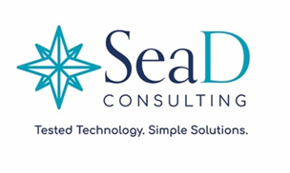

Neal McMillian asked how the restaurants that are to be tested will be chosen? David Williams stated that they will be chosen through random selection using yelp, typing in seafood restaurants and generate a list and randomly choose from that list
Lance Nacio stated that the problem is losing market share, can never attain market share if no one is actually using domestic shrimp, what good is a law if there is no way to enforce it, need to hold people accountable,
Acy Cooper motioned to dedicate up to $71,040 for 4-month contract with SeaD Consulting for shrimp testing and to give the chairman the authority to approve the final contract, 2nd by Lance Nacio. Motion carries.
- The task force considered funding for a STF trip to Washington, D.C.
Acy Cooper motioned to fund Shrimp Task Force travel to Washington, D.C. and the payment for up to 10 STF tickets to the Louisiana Alive event, 2nd by Lance Nacio. Motion carries.
- The Task force considered funding for STF travel to the International Trade Commission hearing on October 15th
Acy Cooper expressed interest in attending and representing the STF at the meeting
Acy Cooper, Jr. motioned to fund travel for STF board members to attend the International Trade Commission Hearing on October 22nd in Washington, D.C., 2nd by Randy Pearce. Motion carries with one opposed, Kristen Baumer.

IX. Public Comment:
Acy Cooper stated that the industry is working with the Department of Ag doing a short video of the shrimp industry that will be shared with the Shrimp Task Force soon; Gene Cavalier stated that the LDAG is working with the Seafood Promotion and Marketing Board to do documentaries on shrimp, crab, oyster, and finfish
The LA Shrimp Festival will be held on October 20th from 11am-7pm at the Broadside called Shrimp Day, goal is to get the Saints to endorse LA Shrimp as their shrimp of choice
Kim Chauvin stated that the Shrimp and Petroleum Fest has been doing this for a while regarding the shrimp served at the festival, wrote letters to the Lt Governor’s office, the SPMB grants funding to festivals, some of these events are using grant monies and serving imported seafood, need to use the local seafood, stated they are talking about other states fining vendors for misrepresentation looking into this for future
X. The next Shrimp Task Force meeting was set for Wednesday, December 18, 2024 for 10:00am at the Terrebonne Parish Council Chambers in Houma
XI. Acy Cooper motioned to adjourn the meeting, 2nd by Randy Pearce. Motion carries.

