
BioDistrict New Orleans
Board of Commissioners Meeting Minutes
October 7, 2020
3 p.m. – 4 p.m.
Location: New Orleans Business Alliance Zoom
Join Zoom Meeting
https://us02web.zoom.us/j/9551395122
Meeting ID: 955 139 5122

- Call to Order at 3:04pm
- Roll Call
Board members present: -Allison Bordelon, Larry Hollier (Nicole Honoree), Sharon Courtney, Lowry Curly, Harold Gaspard, Andy Kopplin, Brad Lambert, Blake Stanfill

- Adopt Agenda for Board Meeting- Agenda adopted

- Introduction of Guest(s)
Waggoner & Ball: Ramiro Diaz, David Waggoner III
NOBIC: Kris Khalil
1532 Canal: Joseph St. Martin
Shibusa Systems: Sally Lindsay
New Orleans Business Alliance attendees: Nolan Marshall III, Jeanette Weiland, Louis David, Victoria Miles, Chandra Teddleton

- Call for Public Input Cards on Agenda Items- no public input cards submitted

- Adoption of previous board minutes
– meeting minutes 1st by Gene D’Amour and 2nd by Allison Bordelon

- Financial Report by Victoria Miles: $33,000 invoiced, received $12,000 with a balance of $21,000. $17,014.57 funds in bank
-request for those who have paid to be invoiced (Victoria Miles of NOLABA will send out the invoices and detailed report to the Chair)

- Chairperson’s Report
- General Updates: Request has been made to not endorse the TIF currently due to the pandemic, but support the TIF post-pandemic.
- The upcoming stormwater management projects will help support the bio-district by supporting land development, increasing investment in health in the area and advancing water management through individual or group projects; opportunity for the buildings and landscape of downtown to be involved in the projects

- Charity Redevelopment Update - 1532 Tulane Partners
-Presentation by Joseph St. Martin, 1532 is a major project downtown with Tulane University being a major project partner. Project footprint is 330,000 square feet of space with currently 300 residential units planned. In negotiation with a charter school (New Horizon) to build out 20,000 square feet for 8-12th grade and daycare provided by Kaleidoscope for 6 weeks to 5 yrs. old. Project on schedule. If anyone has questions, contact Andy Kopplin or Joseph St. Martin.

- Downtown Stormwater Study – Waggoner and Ball
-Presentation by Ramiro Diaz
The stormwater management plan covers land from the central business district to Bayou St. John. The firm worked with DPW to devise a plan that addresses flooding with a goal to reduce flooding near City Hall (Duncan Plaza), Veterans Affairs corridor and Lafitte greenway; used existing master plan of Downtown Development District-DDD (2018) to analyze case study area. Goal is to solve for 10-year flooding events in the region by decreasing street flooding. Plan includes slowing water flow, rerouting water and increased park green infrastructure that will act as water holding zones. Projects can range from parcel level to large scale and could include right of ways, underground water storage and water plazas/parks. Study area included VA, Lafitte Greenway and Armstrong park area. Options to use minimum- public land plan or explore larger proposed plan that includes the downtown area to Bayou St. John with private public partnership and support (Waggoner and Ball will email slides to group; summary slides below).

-Andy: the continual flooding of the downtown area in New Orleans negatively and adversely affects the BioDistrict. Some of the proposed water management projects are actionable. Duncan Plaza could transform into an anchor destination park such as Bryant Park in New York. DDD would like to invest in the park & water management and some of the outlined non-historical building in the area could be remodeled to support the project.
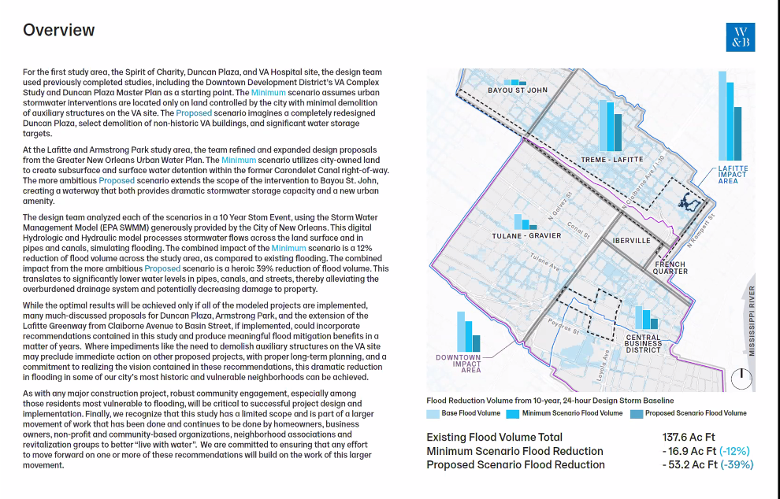
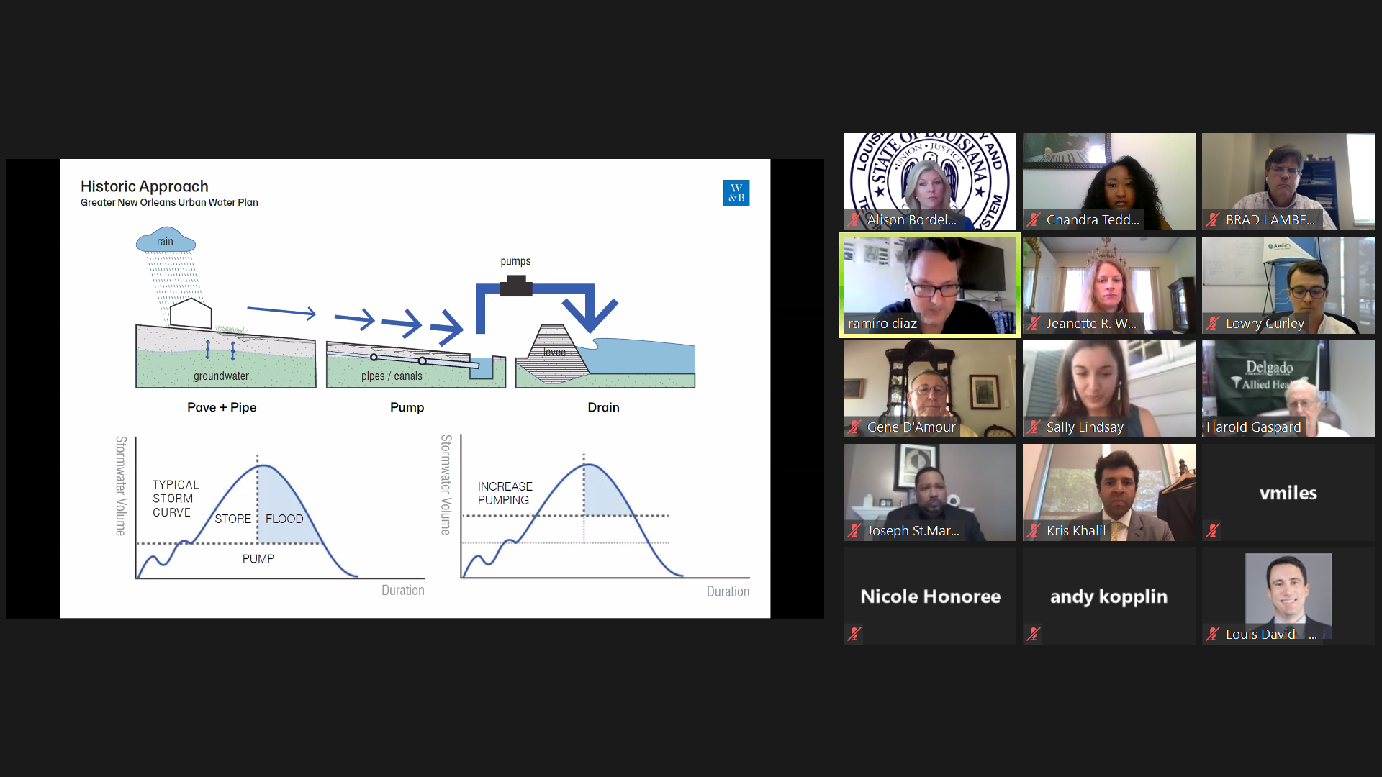
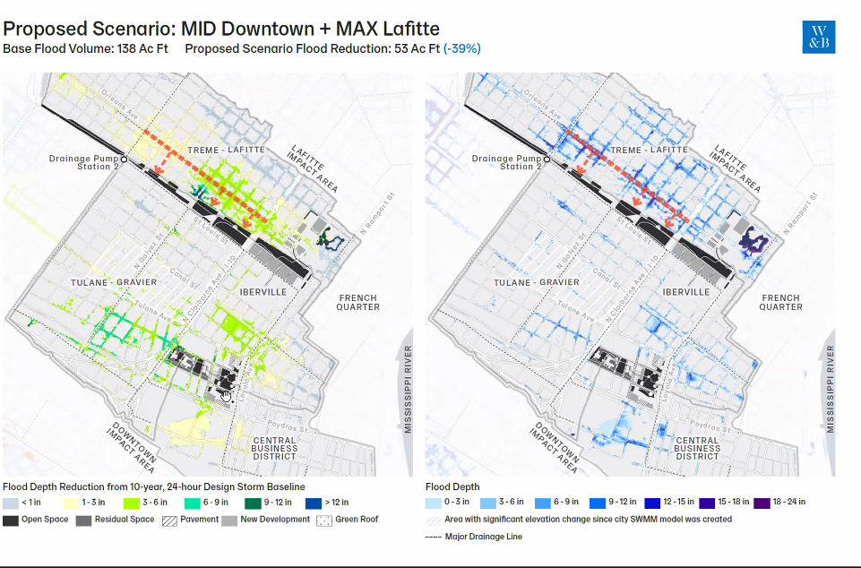
- New Orleans Business Alliance Update
-Jeanette Weiland reported out that NOLABA is submitted the EDA grant for the R&T proposal that would support the build out of the UNO campus. A biotech space building (location where startup tech companies can grow into larger space) proposed.

- Partner Updates
  - New Orleans BioInnovation Center
-Kris Khalil reported out that NOBIC continues to work with rebuilding their workforce program that will launch in 2021 and their 2020 recruitment and strategic plan. The organization received an 83k delta grant and a 1.5 million grant to streamline pathways pilot health (workforce tech support). Continued partnership with BARTA that focuses on COVID-19 and new accelerator program. Working with 3M in a facemask development project and continues to house Tulane public health classes in the space. Most programing has stopped, but 2021 reconvening. Difficult to lease office space and sustainability of NOBIC, but there is an increase in auxiliary services being rebuilt and the lab space is almost fully occupied.
  - Tulane University
-Sharon Courtney reported out for Tulane and highlighted the ongoing Capital Projects and partner project with 1532 as well as NOBIC. Tulane has continued clinical trials and those have increased for COVID-19; 21 COVID-19 trials. Ability to analyze those with COVID-19 currently and those who have had COVID-19. Accepting volunteers for COVID-19 vaccine trial which is taking place in 4 locations working with Mederna (research partnering with LSU, Xavier University highlighting diversity in trials as well).
  - LSU
-Nicole Honoree reported out for LSU and noted that LSU did not shut down and continued to teach and transition students; graduating students within their initial timeframe. LSU working on developing student housing and is interested in mitigating flooding near their campus. This increase of housing coupled with Tulane Warwick housing build will increase residents in the bio-district corridor.
  - LCRC
-Gene D’Amour reported out for LCRC, they are continuing the search for a scientific director who will have 3.6 million via Harrah’s tax funding. Working on NCI designation with conferring MOU in place
  - Xavier
-Gene D’Amour reported out for Xavier University of New Orleans- Xavier has steady enrollment, and taking proper COVID-19 screening and testing measures to make sure faculty, staff and student body. Recently received a 200k grant to work with health FQHC providers
  - Delgado
-Harold Gaspard reported that Delgado has converted to remote-60% needed to convert, with 40% already online. Extensive remote training for faculty and staff and provided computer resources to faculty and students who needed it. Healthcare tracks have increased enrollment with the largest radiology therapy enrollment to date. Clinicals continue after a pause in the spring 2020/summer 2020 sessions, but students graduated on schedule. Delgado & LSU project to renovate the old LSU medical building has shifted. Delgado put out an RFP (Harold will supply the group with the RFP) preference to join with existing nursing school or medical facility in the bio-district corridor; need $34 million to fully renovate and RFP for partner to match at least 13% is needed. Build out must take place in Orleans Parish. Delgado does not expect any furloughs.

- New Business- no new business was presented

- Public Comment(s) no public comments submitted

- Adjournment at 4:09pm

Certification Under JBE 2020-30 Related to Open Meetings
The Board of Commissioners of the BioDistrict New Orleans is unable to operate due to quorum requirements. Therefore, under Section 4 of Proclamation Number JBE 2020- 30 of March 16, 2020, the BioDistrict board will conduct the Wednesday, October 7th, regular meeting of the Board of Commissioners by telephone conference. The public is invited to observe and provide input to the Board via email. A person may email a comment related to a particular actionable agenda item upon which a vote is to be taken. Emails should be sent to cteddleton@nolaba.org. Please include your name and the agenda item you wish to comment on.

