Crab Task Force Meeting Minutes
Tuesday, August 20, 2024, 10:00am
Terrebonne Parish Government Tower
8026 Main Street
Houma, LA

I. Pledge of Allegiance
II. Meeting called to order at
III. Roll Call and introduction of guests
Voting Members Present:
Laquita Meek
Trudy Luke
Al Cassagne
Rodney Parfait
Edward Frekey
Britney Breaux
Dannon Lacoste

Voting Members Absent:
Eric Blanchard
Chalin Delaune
Sheb Callahan
Joey Edgar
George Jackson

Non-Voting Members Present:
Peyton Cagle
Jack Isaacs
Davis Madere
Haley Gambill in for Melissa Daigle
Non-Voting Members Absent:

IV. Edward Frekey motioned to approve the April 16, 2024 meeting minutes, 2nd by Al Cassagne. Motion carries.

V. Edward Frekey motioned to approve the August 20, 2024 meeting agenda, 2nd by Al Cassagne. Motion carries.

VI. Financial Report
Remaining Fund Balance- $97,380
Remaining Budget Balance- $97,380

Edward Frekey motioned to approve the financial report as presented, 2nd by Al Cassagne. Motion carries.

VII. New Business
- Peyton Cagle provided a presentation on the 2025 proposed derelict crab trap closure areas

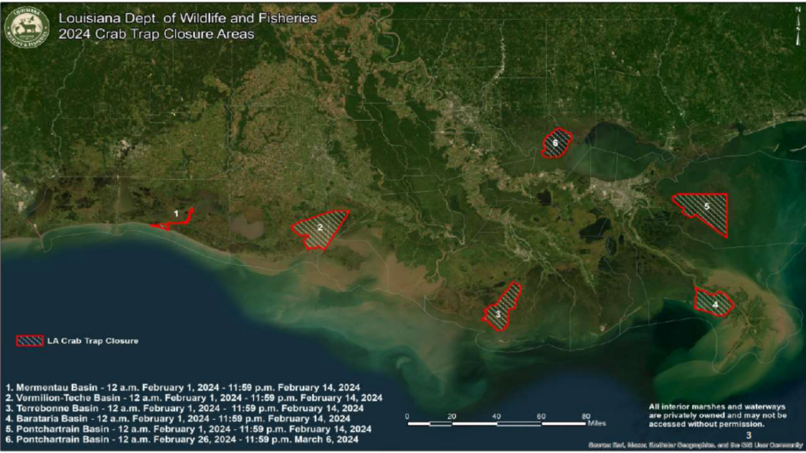

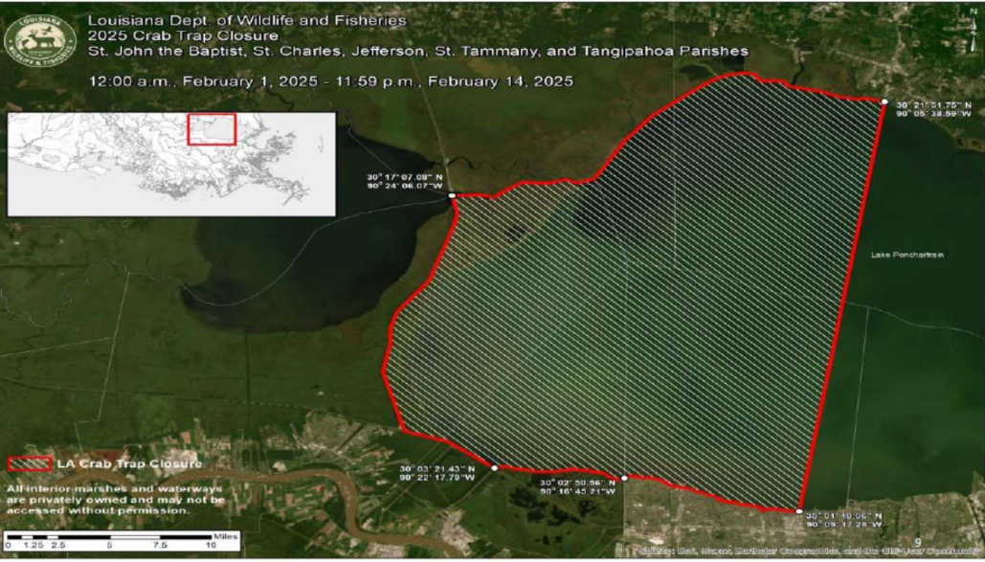
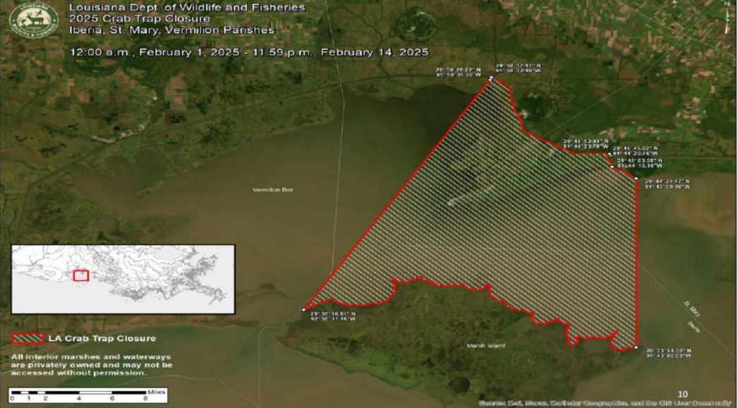
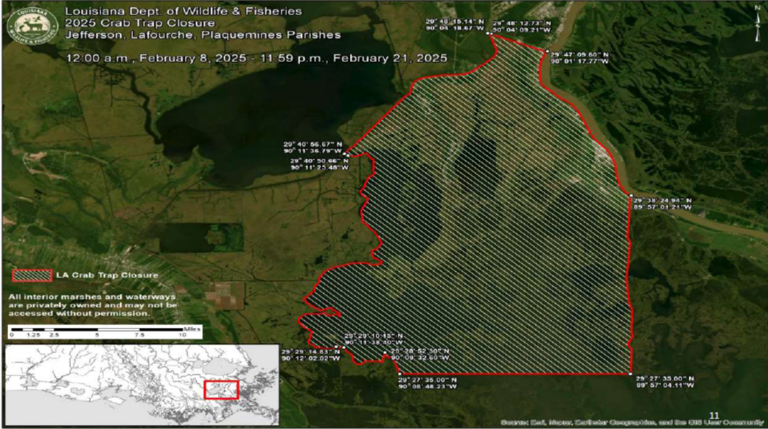
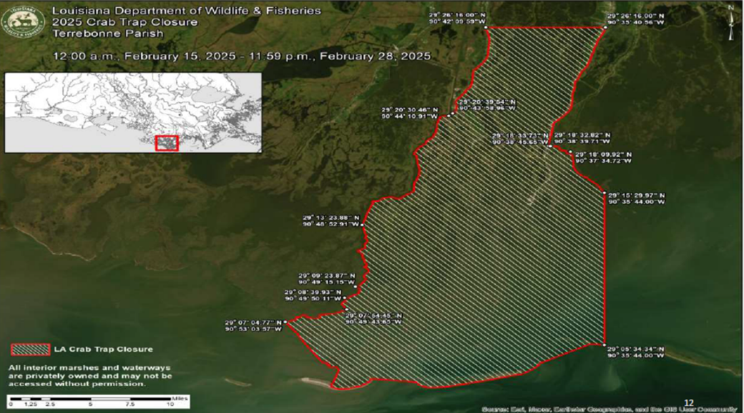
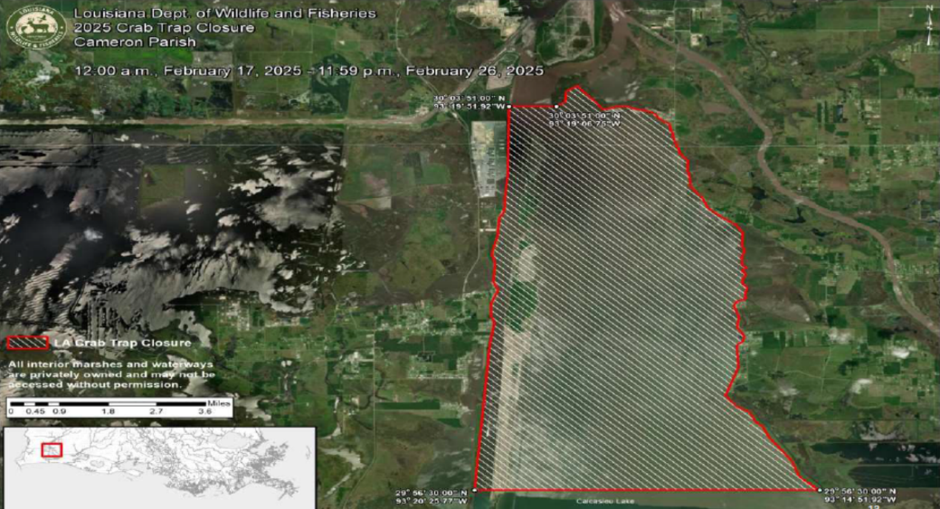
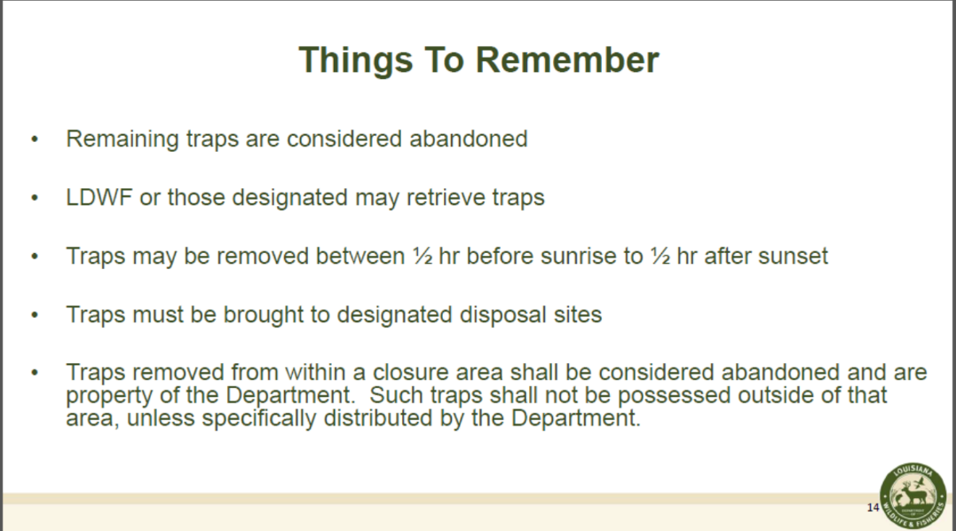
- The task force heard a quick update on the Restore LA Small Business Loan Program
Cullen Curole was not able to attend the meeting but provided an update via text: Generically, the program has funded about one quarter of the active applications. State funding is slow and fisheries files working in unison with LDWF Equipment Grant Program to ensure no duplication of benefits
Trudy Luke stated that if a person is denied for the Equipment Grant Program that those individuals should receive a letter of denial and the reasons why they are denied
- Doug Daigle presented a resolution to the task force that would support the continued work on Gulf hypoxia
Resolution
Adopted by the
Louisiana Blue Crab Task Force

Expressing support for continued efforts to reduce the size of the Gulf Hypoxic Zone
WHEREAS, the spread of an area of low oxygen in the Gulf of Mexico, commonly known as the "Dead Zone", is a serious concern to Louisiana's commercial fishing and seafood industries as a threat to this important national resource; and
WHEREAS, the spread of low oxygen and high nutrient levels in coastal waters can impact the health, life cycles, and reproductive success of estuarine and offshore species that are important for the function of the Gulf of Mexico fishery and the seafood industry in our state; and
WHEREAS, Louisiana is the number one domestic supplier of blue crab in the U.S., and the state's blue crab fishery is the first and only in the nation to be certified sustainable by the Marine Stewardship Council; and
WHEREAS, the Louisiana Crab Task Force, composed of members of the seafood industry, state agencies and scientists, is charged with advising the Louisiana Department of Wildlife & Fisheries and the Louisiana Wildlife & Fisheries Commission on the management and development of the crab industry in our state; and
WHEREAS, the state of Louisiana has been working with other states in the Mississippi River Basin as well as government agencies and the private sector to address this serious problem since 1997, by cooperative efforts to reduce nutrient loading to the Mississippi River and the Gulf that fuels the growth the hypoxic zone; and
WHEREAS, the new Action Plan agreed to by Louisiana and the other states on the Gulf Hypoxia Task Force calls for an increased level of action to reduce the growth and spread of the "Dead Zone", and the state of Louisiana will receive an additional $20 million under the BP settlement for reducing nutrient loading to coastal waters;
THEREFORE, the Louisiana Crab Task Force expresses its support for continued action by Louisiana in collaboration with upriver states, federal agencies, and private industry under the Action Plan and related efforts to reduce the size and growth of hypoxia in our coastal waters.
Edward Frekey motioned to pass and approve the resolution to support the continued work on Gulf hypoxia as presented, 2nd by Trudy Luke. Motion carries.
VIII. Public Comment- no comments
IX. Next meeting set for Tuesday, October 22, 2025 for 10:00am at the Terrebonne Parish Council Chambers- Government Tower
X. Al Cassagne motion to adjourn the meeting, 2nd Edward Frekey. Motion carries.

