Quarterly Meeting Minutes
Gerri Hobdy, Chair
Baton Rouge

Rex Alexander
Lake Charles

Marguerite Anderson
West Monroe

Pamela Breaux
Lake Charles

Pamela Bryan
New Orleans

Dwayne Carruth
Baton Rouge

Stephen Carter
Baton Rouge

Karen Courtman
Shreveport

Michael Echols
Monroe

Robert Fisher
La Place

Lagena Gore
Dry Prong

Angela King
New Orleans

George Marks
Arnaudville

Barbara Motley
New Orleans

Michael D. Robinson
Baton Rouge

Karen Dean Sharp
Sterlington

Larry Eugene Thompson
Winnsboro

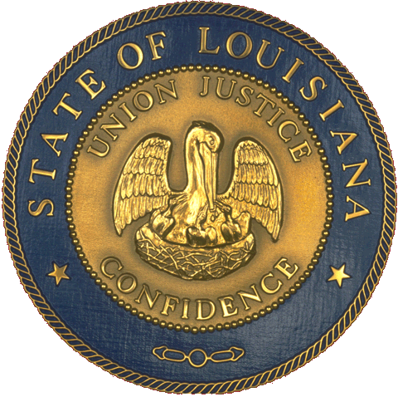

State of Louisiana
Office of the
Lieutenant Governor
Department of Culture, Recreation, Tourism
Office of
Cultural Development

Louisiana State Library, Baton Rouge, LA
Tuesday, April 23, 2013

Council Members present: Gerri Hobdy, Robert Fisher, Rex Alexander, Karen Sharp, Marguerite Anderson, Larry “Gene” Thompson, and Barbara Motley

Council Members not present: Michael Echols, Michael D. Robinson, Dwayne Carruth, and Gena Gore

LDOA Staff present: Pam Breaux, Dana La Fonta, Kelly Pepper, Gaye Hamilton, Danny Belanger, Pearlie Johnson, and Maida Owens

Guests present: Cathy Hernandez, Teresa Parker-Farris, Ann Snyder, Alia Casperne, Margaret Harmon, Dr. Rhonda Perkins, Alia Casborne, Margaret C. Harmony, Latanya G. Monroe, Tina Begnaud, Mojo, and Priscilla Metoyer

I. Call to Order and Welcome
Chairman Hobdy called the meeting to order at 10:19 a.m.

II. Approval of Minutes
Upon motion by Karen Sharp, which was seconded by Marguerite Anderson, the minutes were unanimously approved.

III. Chairman’s Report
Chairman Hobdy provided a report on the LSAC’s role in the selection of a new executive director of the Arts Division. She thanked search committee members for their work. The process yielded many competitive applications. The Lt. Governor joined the Council for its interview of finalists. Cathy Hernandez was selected as the next executive director of the Arts Division. Gena Gore, Michael Echols, Barbara Motley, Glenda Toups, Dwayne Carruth, and Michael Robinson joined Chairman Hobdy on the search committee.

Chairman Hobdy also reminded LSAC members that financial disclosure reports are due to the Ethics Commission by May 15. Further, the required ethics course that members must take is available online. She asked members to submit copies of their certificates of course completion to the Office of Cultural Development/Division of the Arts when finished.

IV. Committee Reports
Advocacy—The Louisiana Citizens for the Arts will conduct legislative visits today. Each region of the state is represented.

V. LDOA’s Director’s Report
Legislative Update—Pam Breaux reported on HB1 as it pertains to the arts budget. The executive budget recommends level funding for the Statewide Arts Grant Program and the Decentralized Arts Funding Program. The legislature has already begun its deliberations on the proposed budget.

Further, the Legislature has deliberated on the Governor’s tax swap package. There are several sales tax exemptions currently contained within law that would impact the arts if eliminated. Museums and theaters are exempt from charging sales tax. In addition, cultural districts do not charge sales tax on the sale of original one-of-a-kind artworks. The original tax swap package is currently off the table; however, the legislature is still considering tax reform options. To this end, it is important to stay informed about how other options might impact the arts.

Breaux thank LSAC members of assisted in work on Culture Connection. Members selected winners of the state arts awards.

Breaux also reported on the Louisiana Creative Communities Initiative. Ten communities have been selected to participate in the program, which pairs those communities with coaches and an opportunity to develop locally driven creative placemaking plans and programming. The communities will present their results this fall.

VI. LDOA Staff Reports
Grant Making—Kelly Pepper presented a report on the statewide arts grant program. The division has received 64 applications requesting funding. The LSAC executive committee recently reviewed and approved a pool of panelists to review grant applications. The panel review process will be conducted online this year, and funding recommendations will be provided to the LSAC at its June meeting.

Cultural Districts—Gaye Hamilton presented a report on the cultural districts program. She provided the council with a newly developed document that summarizes recent program results.

Folklife—Maida Owens presented the folklife program report. The Creole State Exhibit has been reinstalled in the Capitol Breezeway. Further, she is also working with the State Museum Education Department to produce an Education Guide for Capitol Park fieldtrips; she will also participate in a training session for Capitol Visitor Information employees. In addition, she continues to work on the enhancement of the Folklife in Louisiana website, which includes adding navigation features and multimedia components

Percent for Art—Dana LaFonta reported on percent for art projects completed as well as those in progress now. She also provided a list of projects that will be embarked upon next. Eighty-one artists have participated in the program, and 121 direct purchases have been made and installed in state buildings.

Arts in Education—Danny Belanger traveled to Washington, D.C., for the Poetry Out Loud national recitation contest. Louisiana was represented by Alexis Granville. He also reported that the ICI program is completing its third year. Teachers and artists will be trained this summer in preparation for the fourth and final year of this four-year pilot.

VII. NASAA Report
Pam Breaux reported that the NASAA Assembly will be in New Orleans in the fall of 2014. Dates and conference hotels will be selected this summer.

VIII. LPA/LCA Report
Pam Breaux reported that the LPA will convene a planning retreat in late June. By that time, the new officers will be in place. In other news, Tommy Usrey is the 2013 winner of Americans for the Arts “Arts Action Award,” which is given in honor of arts advocacy work each year.

IX. New Business
Chairman Hobdy reminded the council to participate in the remaining Culture Connection events for the day. Further, she invited the incoming Division of the Arts executive director, Cathy Hernandez, to share comments with the council. Hernandez stated that she is looking forward to working with staff and council to move the arts forward in Louisiana.

Chairman Hobdy ended the new business report by commending the staff for their work.
X. Public Comment
(None)

XI. Adjournment
Chairman Hobdy adjourned the meeting at 11:14 a.m.

