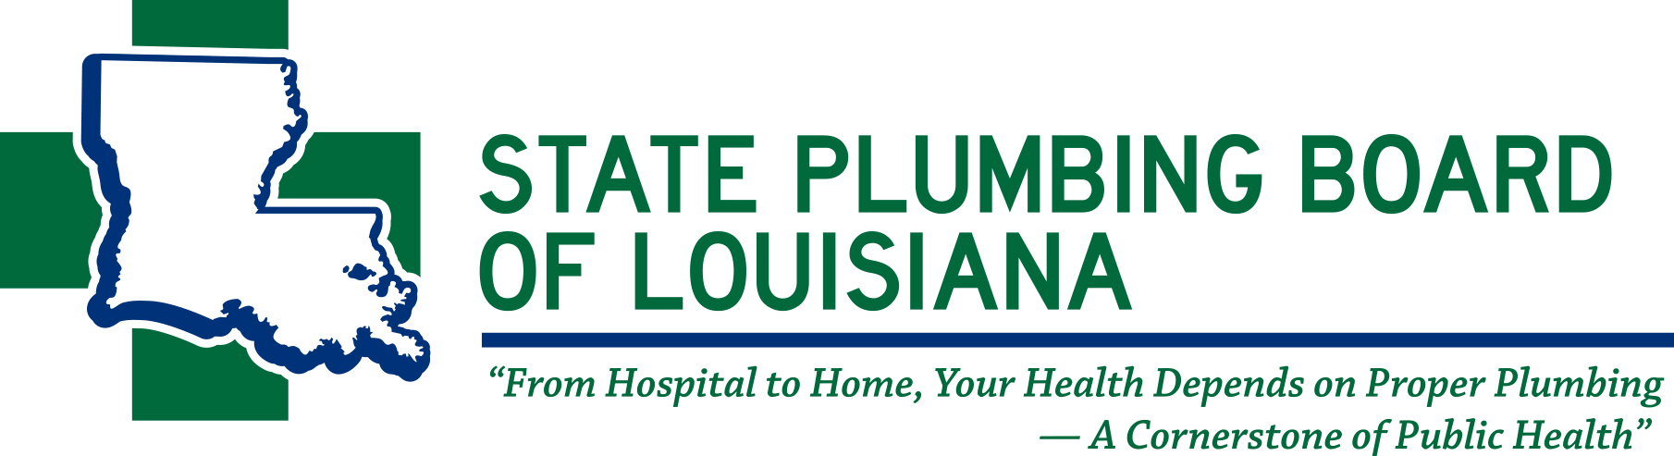
11304 Cloverland Avenue • Baton Rouge, Louisiana 70809
Phone: (225) 756-3434 • Fax: (225) 756-3433
www.spbla.com

BOARD MEMBERS:

TERRY SMITH
CHAIRMAN
BATON ROUGE

KELLY CRAFT
VICE CHAIRMAN
LAKE CHARLES

RICKEY FABRA
SECRETARY/TREASURER
METAIRIE

CARL BOURGEOIS
GONZALES

GERALD LACOUR
ALEXANDRIA

LARRY REILING
COVINGTON

TREY GIGLIO
SHREVEPORT

JAKE CAUSEY
BATON ROUGE

JOHNNIE MARCADE
NEW ORLEANS

ASHLEY J. TULLIER
EXECUTIVE DIRECTOR
BATON ROUGE

TO: BOARD MEMBERS
ADVISORY COMMITTEE MEMBERS
LOUIS ROBEIN/ATTORNEY
ENFORCEMENT OFFICERS
GUESTS

FROM: ASHLEY J. TULLIER
EXECUTIVE DIRECTOR

SUBJECT: SPECIAL BOARD MEETING DATE

The Special Board Meeting of the State Plumbing Board of Louisiana is scheduled as follows:

DATE: THURSDAY, MAY 14, 2020 via Zoom

TIME: 10:00 A.M.

PLACE: STATE PLUMBING BOARD’S OFFICE
11304 CLOVERLAND AVENUE
BATON ROUGE, LOUISIANA 70809

If you have any questions or agenda item requests, please contact Ashleigh W. Cambre at
(225) 756-3434.

Sincerely,
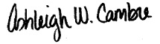
Ashleigh W. Cambre
Administrative Coordinator

