Germantown Colony

Museum

Notice of Meeting

Advisory Board

Thursday, August 6, 2020

4:30 p.m.

Minden Chamber of Commerce

110 Sibley Rd Minden, LA

MEETING IS OPEN TO THE PUBLIC

318-377-6061

P. O. Box 178, Minden, LA 71058

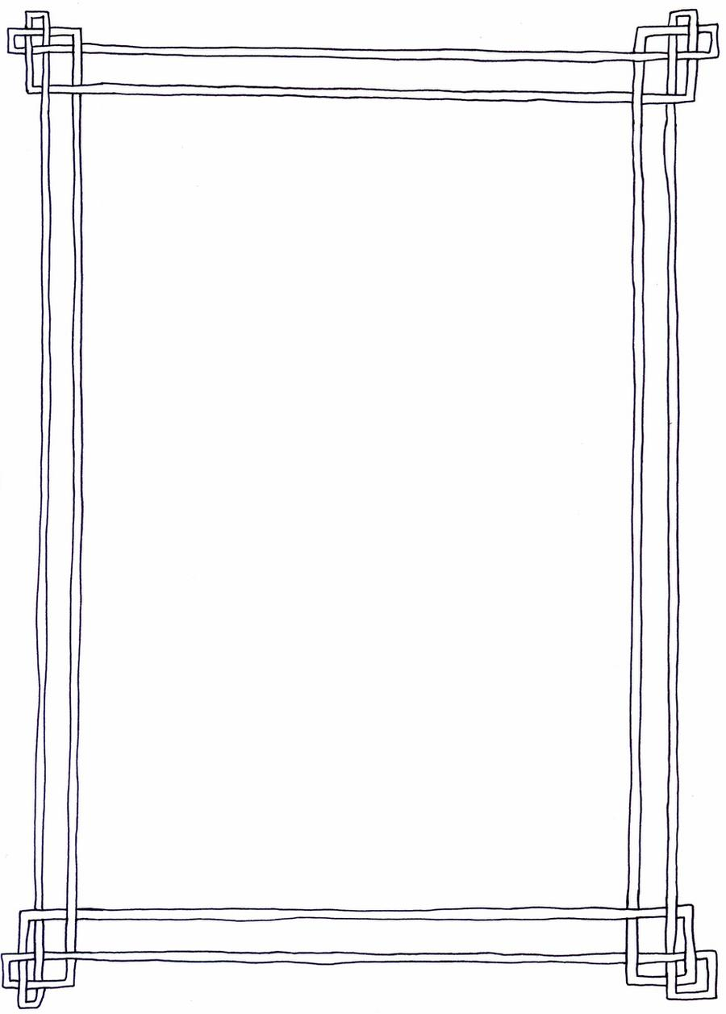

[This Photo](http://speculumhistoriae.deviantart.com/art/High-Medieval-Border-297221733) by Unknown Author is licensed under [CC BY-NC](https://creativecommons.org/licenses/by-nc/3.0/)