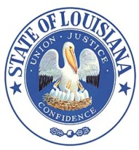 Louisiana State Board of Embalmers
and Funeral Directors
New Orleans, LA
Suite 1232, The Executive Towers
3500 N. Causeway Blvd.
Metairie, LA 70002
504.838.5109 www.lsbefd.state.la.us
FAX: 504.838.5112 Toll free: 888.508.9083
Notice of Meeting
Wednesday – September 11, 2019
9:00 AM
Meeting of the Board

Agenda
9:00 AM
1. Agenda - Call to order / opening remarks / Pledge of Allegiance
Roll call –
Public Comment - Public comment cards are available for anyone who wishes to address the Board. Please
fill out a comment card and give to any of the staff or a board member in order to
be recognized during the meeting.
Presentations
There are no presentations scheduled for this meeting.

Correspondence and/or Requests
There are no requests for this meeting

Hearings and/or Compliance
2. Pending - Formal Hearing scheduled for October 8, 2019 – consideration of the Board – vote to move
forward

3. Hearing procedures – notification for hearing officer for formal hearings

Board Office Update
There are no updates for this meeting

Board-Staff
4. New Business / Discussions –
Conclusion of meeting
Next tentative meeting date set for October 8, 2019

