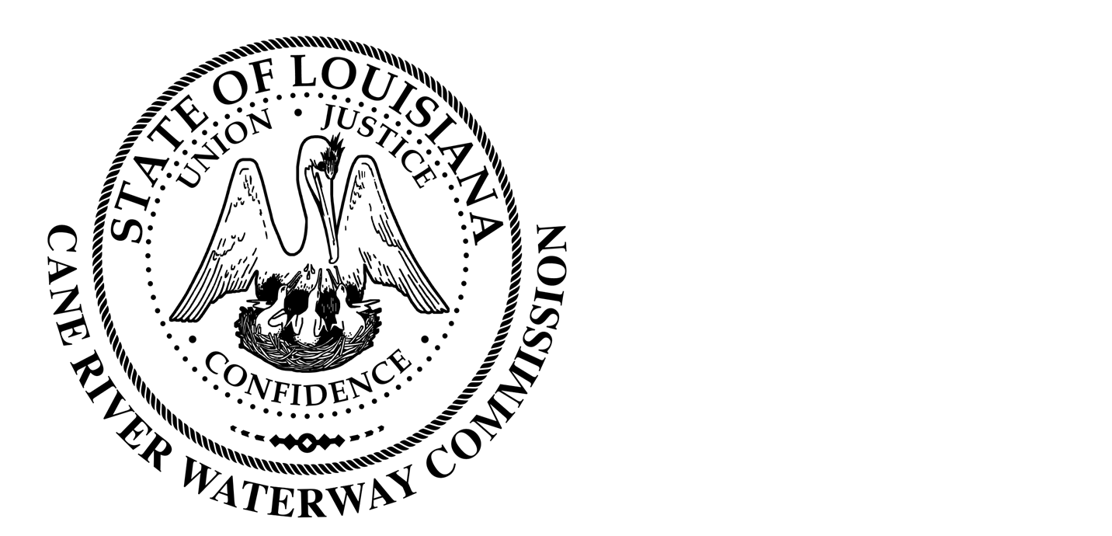
Cane River Waterway Commission
Minutes
March 18, 2024

There was a public hearing of the Cane River Waterway Commission on March 18, 2024, at 6:00 pm located at 244 Cedar Bend, Natchez, Louisiana.
The hearing was called to order and roll was called with the following members being present: Mr. Rhodes, Mr. Methvin, Mrs. Banks, Mr. Methvin, Mr. Paige and Mr. Wiggins.
Also present was Director of Operations Jason Adcock and Attorney Tommy Murchison.
Mr. Adcock presented the Finance report. Upon motion by Mr. Wiggins and seconded by Mr. Paige the board approved the Finance report .
The board approved the minutes of January 30, 2024 meeting.
Mr. Adcock advised the board that after the approval from January to look for a solution to the meeting domicile that the best option would be to build a new office on the land owned by the Commission at Shell Beach. Mr. Adcock asked to have Monceaux, Bueller and Ass engineer and handle the bid of the project. On motion by Mrs. Banks and seconded by Mr. Wiggins and unanimous vote by Mr. Rhodes, Mr. Methvin, Mr. Paige, Mrs. Banks and Mr. Wiggins the board agreed to hire the Engineering firm Monceaux, Bueller and Associates to handle the design and bid process.
Mr. Adcock stated that the Washington Street project was almost complete and that the maintenance and upkeep of the grass would need to begin soon. The board agreed to add the maintenance and upkeep to the Contract of Mayeaux Rangers.

There being no further business to come before the Board, upon motion by Mr. Paige seconded by Mr. Methvin and unanimous vote by Mr. Wiggins, Mrs. Banks, Mr. Methvin, Mr. Paige and Mr. Rhodes, the meeting was adjourned.

________________________________
Approved by
__________________
Date

