Atchafalaya Trace Commission Regular Meeting
Wednesday, November 7, 2018 • 10:00 AM
Louisiana State Library, 702 North River Road, Capitol View Room, 5th Floor Baton Rouge, LA

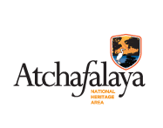

AGENDA

Call to Order/Pledge of Allegiance

- Agenda Approval

- Approval of 09/12/18 Regular Meeting Minutes

- Administrative Report, Budget Update
and Outreach Activities Steven Fullen

- Projects’ Progress Report

- Committee Activity Reports
- Natural & Outdoor Resources
  - Atchafalaya Basin Update
- Education
- History & Culture
- Sustainability

- Other Business
- Social Media/Website Justin Owens

- Commissioner Announcements

- Adjourn

