SOUTHERN HIGH-SPEED RAIL COMMISSION
EXECUTIVE COMMITTEE MEETING
Embassy Suites
Ridgeland, Mississippi
February 18, 2011

Kay Kell
Robert Lake
Martin Bruno
Toby Bennington
Phil Jones
Chris Miller

- Review status of outstanding dues
- Status of Houston-Baton Rouge Grant
- Status of New Orleans to BR project invoices for BKI
- Issue of Amendmetns to By-Laws/Ex. Comm meeting procedures
- Review invoices
- Set next meeting
Meeting called to order at 1:08 pm – No quorum
- Outstanding dues – talked about the status of outstanding dues for Alabama and Mississippi. Bob Lake outlined the efforts and plans for Alabama dues. Toby Bennington said he would try to arrange a meeting with new ALDOT Director. Mississippi action plan is to wait on further advocacy at state levels.
- Look to hiring a lobbyist.
- Meeting of full commission to be held quarterly instead of every other month.

SOUTHERN HIGH-SPEED RAIL COMMISSION
FULL COMMISSION MEETING
Embassy Suites
Ridgeland, Mississippi
February 18, 2011

Meeting was called to order by Chairman Kay Kell at approximately 2:13 p.m. followed by the Pledge of Allegiance led by Martin Bruno. Roll was called by Christopher Miller, Assistant Executive Director, of South Alabama Regional Planning Commission (SARPC) and a quorum was confirmed. Chairman Kay Kell welcomed all Commissioners and asked each commissioner and guest to introduce themselves.

ALABAMA
Robert Lake
Billy McFarland
Greg White
Toby Bennington

LOUISIANA
Gary Devall
Martin Bruno
Colonel Phil Jones
Representative Michael Jackson - proxy to G. Devall

MISSISSIPPI
Charles Ozier
Kay Kell
Representative Tommy Woods – proxy to Kay Kell

SARPC
Chris Miller
Grace Crawford

GUEST
Knox Ross, Pelahatchie, MS
Paul Waidhas, BKI
Dale McDonald, PB
Ray Ballentine, Wilbur Smith

Chairman Kay Kell asked for a motion to approve the minutes of the December 10, 2010 Full Commission Meeting. It was motioned by Commissioner Gary Devall to approve the minutes and seconded by Robert Lake. The motion carried unanimously.

OLD BUSINESS

Discussion: Status of outstanding dues payment from Mississippi and Alabama.

Alabama: Bob Lake updated the efforts of the Alabama delegation with a recent meeting with ADECA to ask for ALDOT to pay funds. Billy McFarland also indicated that he had positive conversations with ADECA.

Mississippi: Charles Ozier stated that he has had several conferences with Monica Ramsey, MDOT, regarding gathering support for SHSRC membership and payment of annual dues. Ms. Ramsey will help with setting a meeting with Dick Hall.

LOUISIANA- Update on Baton Rouge to New Orleans
Paul Waidhas gave an update on the status of final invoices. BKI submitted their draft report in March and the final report in October and no comment from FRA until invoices were submitted. A teleconference with Katherine Dobbs, FRA, is scheduled for closeout of the project with three options available.

Houston to Baton Rouge HSP Rail Grant – (Corridor Study) Katherine Dobbs indicated that we were denied because we didn’t show a complete list of deliverables. The grant reviewer’s thought we didn’t get to the next level of service so we will have to demonstrate that service on our next submission.

BR to NO Compact Group - Commissioner Phil Jones gave an update on the Baton Rouge to New Orleans Compact Group. A mid-December meeting was held with about 15 people representing both cities with Representative Michael Jackson acting as the chairman with the focus being developing an economic corridor with a rail emphasis component. The group will pursue a grant to hire an Executive Director to oversee the compact. The insurance rate is an issue for non-scheduled routes.

Discussion: Continuation of SHSRC operations
Gary Devall asked for a financial overview given the outstanding dues from Mississippi and Alabama. In the past if a state had not paid their dues the commissioners from that state would not be reimbursed. Gary Devall made a motion for all commissioners to be reimbursed and seconded by Martin Bruno. The motion carried unanimously.

Discussions continued about cost saving measures for the Commission. Martin Bruno moved that meetings be held quarterly for the Full Commission and looking at alternative venues other than hotels. The ExComm meetings will be held by telephone conference or as needed. It was decided that to also invite local officials to the quarterly meetings for their support. The next quarterly meeting will be held in Alabama with an invitation to Anniston. A new telephone and email list to be sent out. Charlie Ozier suggested that he will contact Chris Miller to disseminate to the full commission when he has news to share with the Commission. Phil Jones requested that SARPC look at any cost saving measures for meeting expenses. It was explained that SARPC has cut back on staff commitments and copier expenses and will continue to look for savings.

NEW BUSINESS

State Reports-

Alabama: Toby Bennington read a letter from Johnny L. Smith, MPO Chairman for the East Alabama Regional Planning and Development Commission dated January 3, 2011, addressing the support for high speed rail in Alabama.

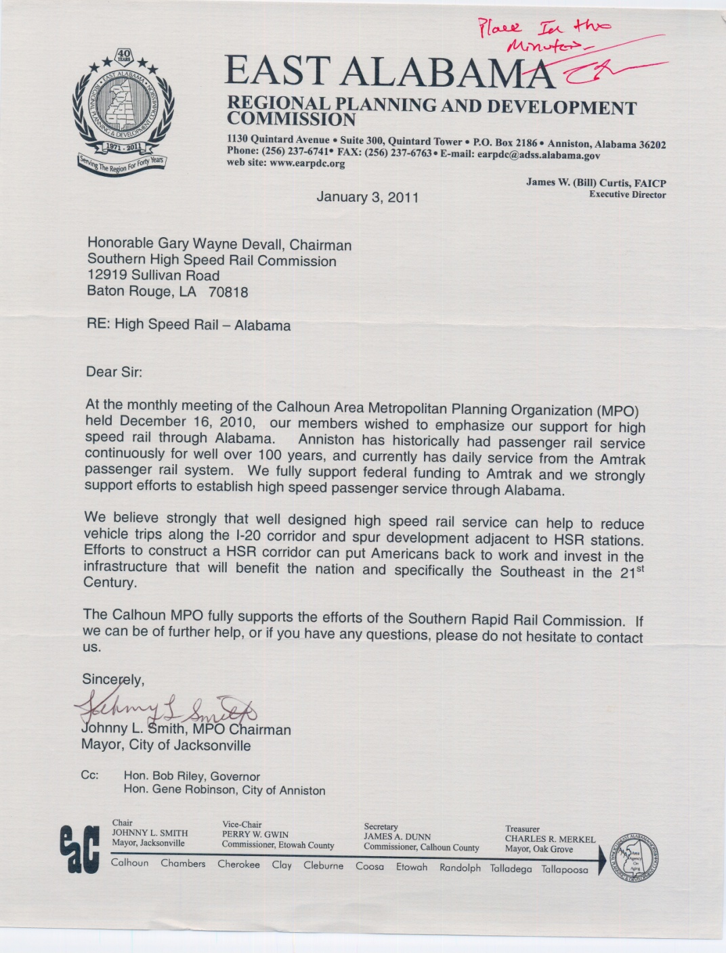

Louisiana: Phil Jones discussed the Compact Group meeting held in December focusing efforts on economic corridor regarding problems in “Gateway Project” in New Orleans with improvements to the rail system. The Compact is trying to hire an Executive Director with federal grant funds. The group received a positive reaction to the Compact from Amtrak for their efforts.

Gary Devall requested Commissioners to make any contacts in Washington, D.C. for support of Amtrak funding.

FINANCE AND ADMINISTRATION

The Chairman asked Mr. Miller to give a detailed Financial and Administration report and Accounts Payable report. After the report the Chairman asked for a motion to approve the report and payment on the invoice submitted in the report by SARPC and BKI invoice 21 and 22. Martin Bruno motioned to approve and Robert Lake seconded. The motion carried unanimously.

Future Meeting Dates
Executive Committee and Full Commission meeting on April 29,, 2011 in Montgomery, Alabama.

Adjourned

